**COMP3354 ASSIGNMENT 2**

**JAIN RAJAT, 3035453684**

Chapter 6 Exercise:

Question 8.

1. Using rnorm to generate x and noise vector e.

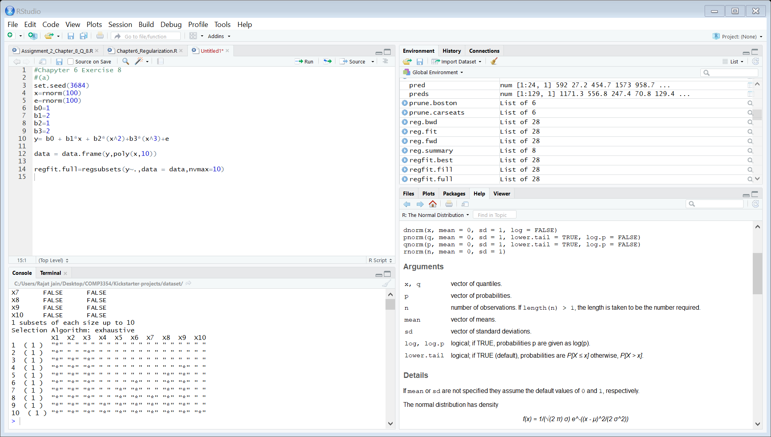

1. Generating y:

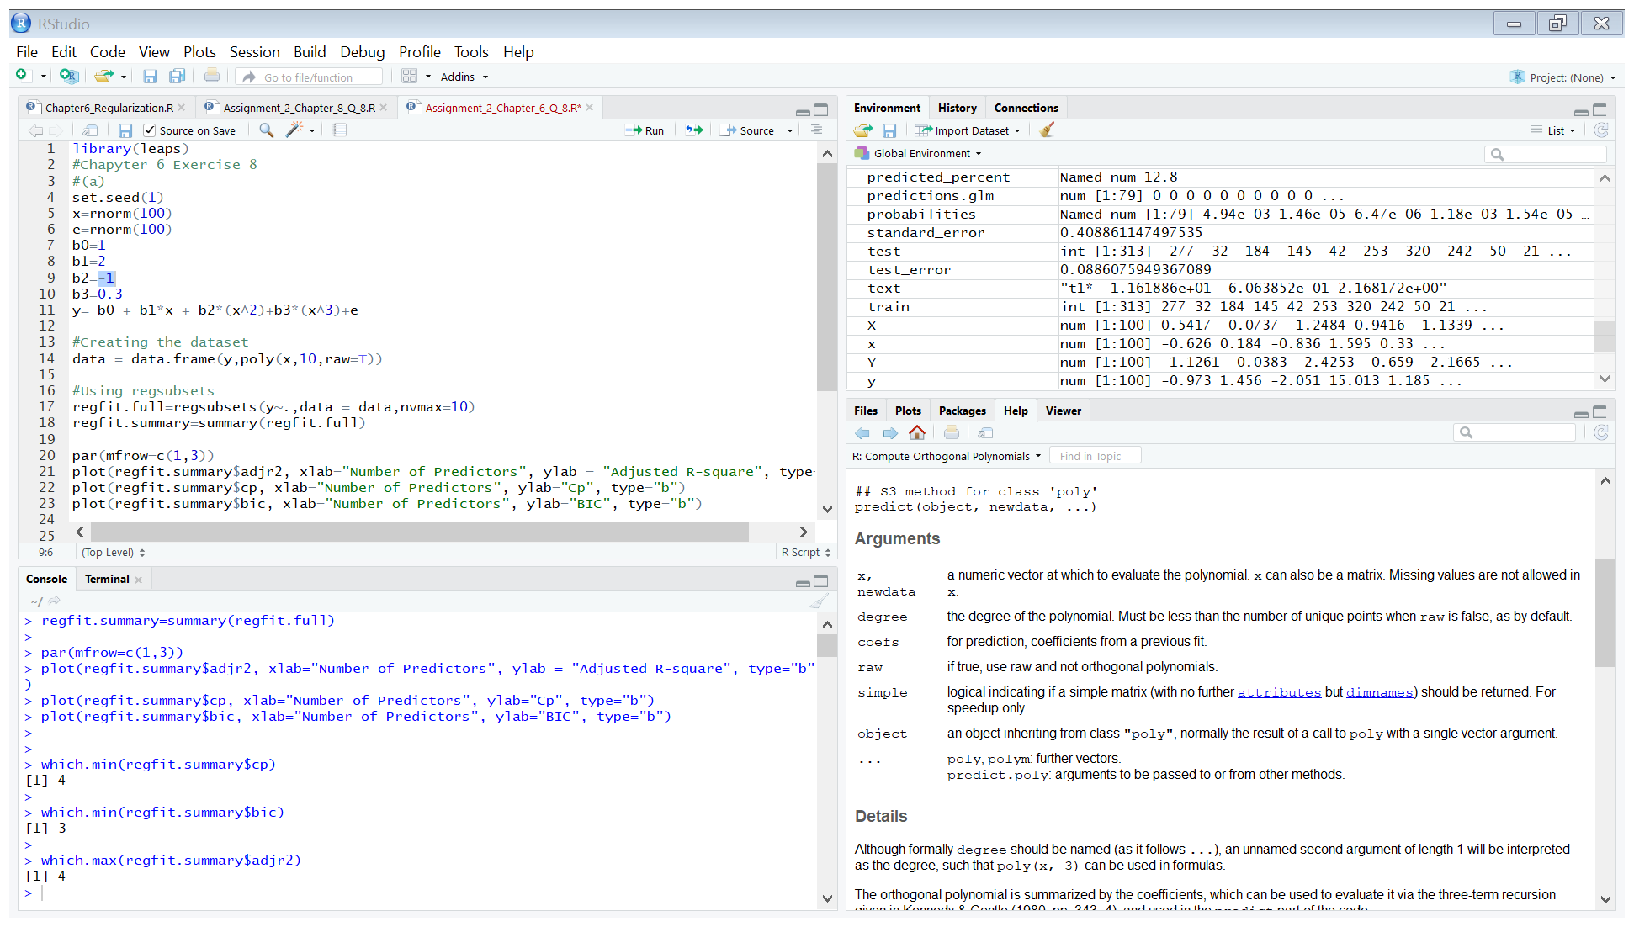

1. Merging x and y to create the dataset and applying regsubsets to find models with best subset selection.

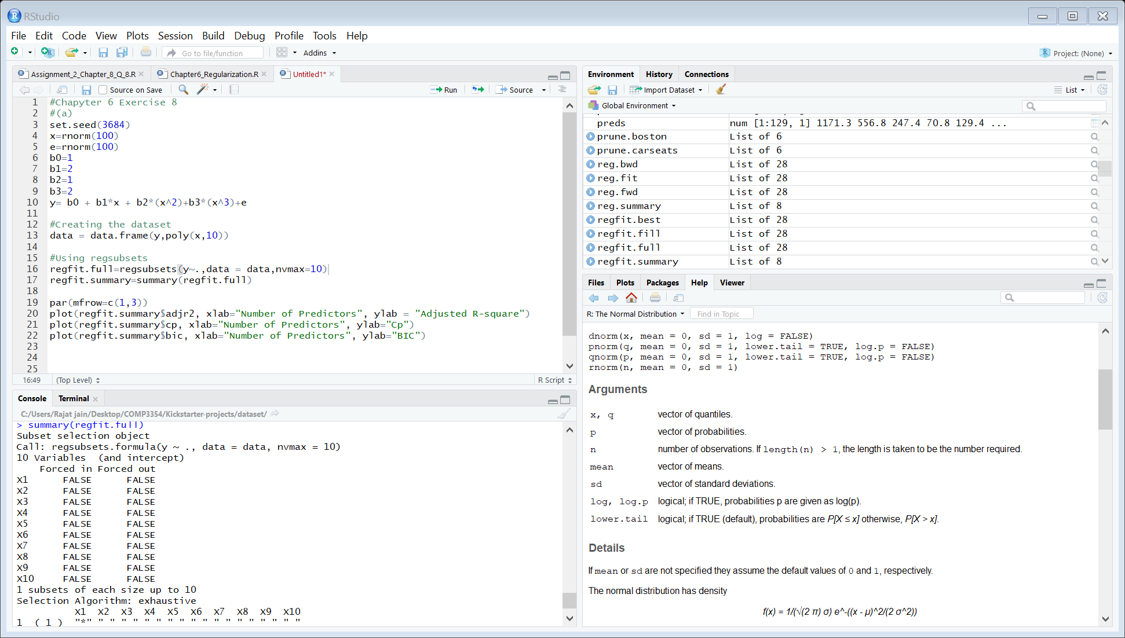

Finding the best model using Adjusted R-Square, Cp and AIC.

1. Best model using Adjusted R-square: the model should have 3 predictor.

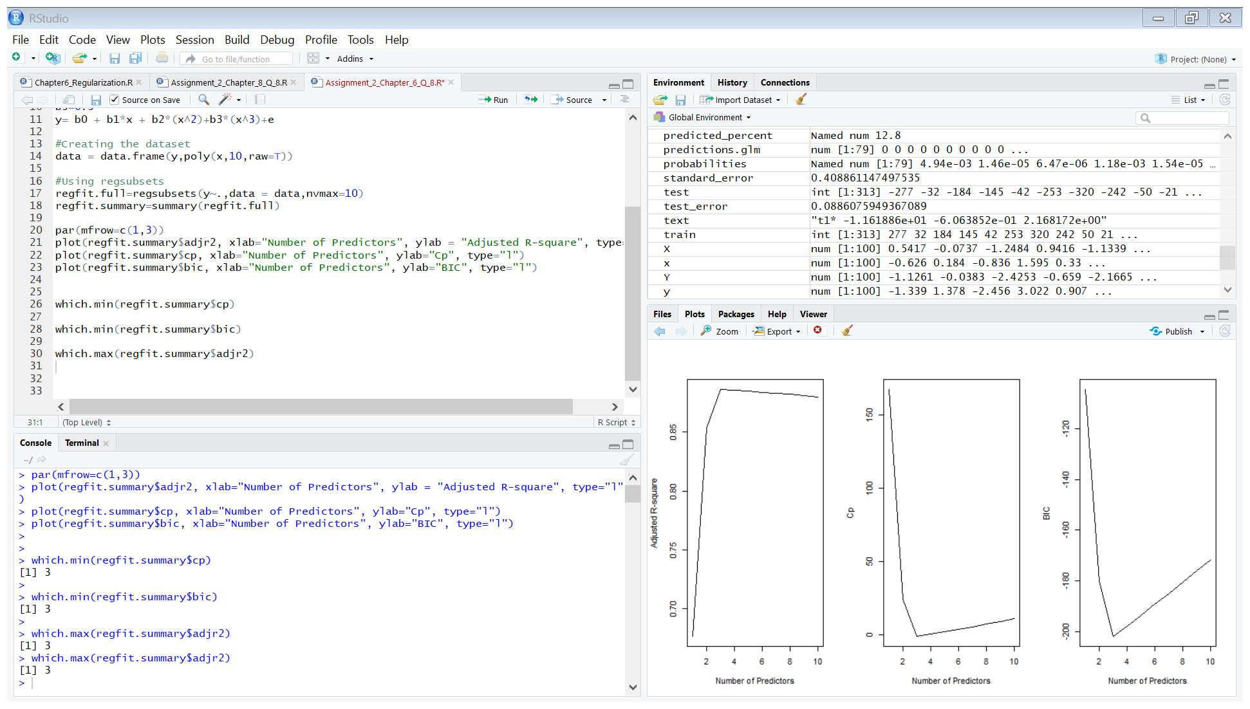

1. Best model using Cp: the model should have 3 predictors.

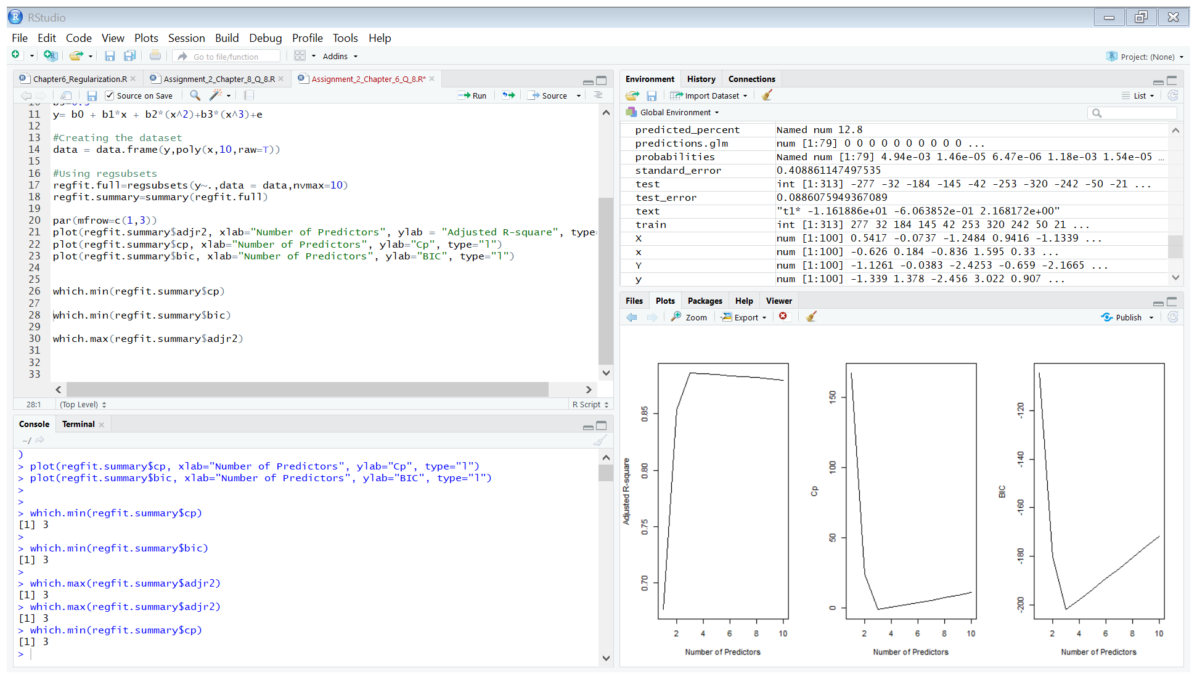

1. Best model using BIC: the model should have 3 predictors.

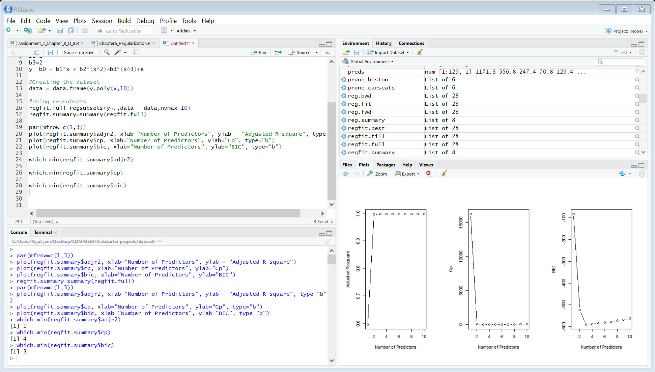

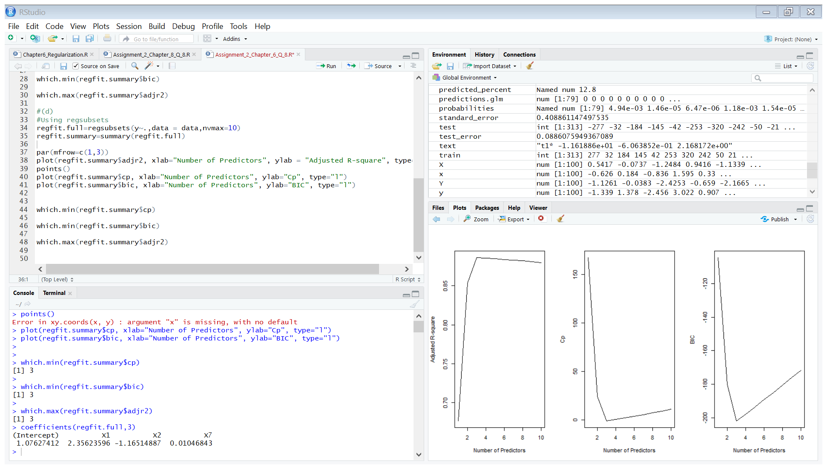

* The methods selects 3 predictor variables but selects x7 over x3.

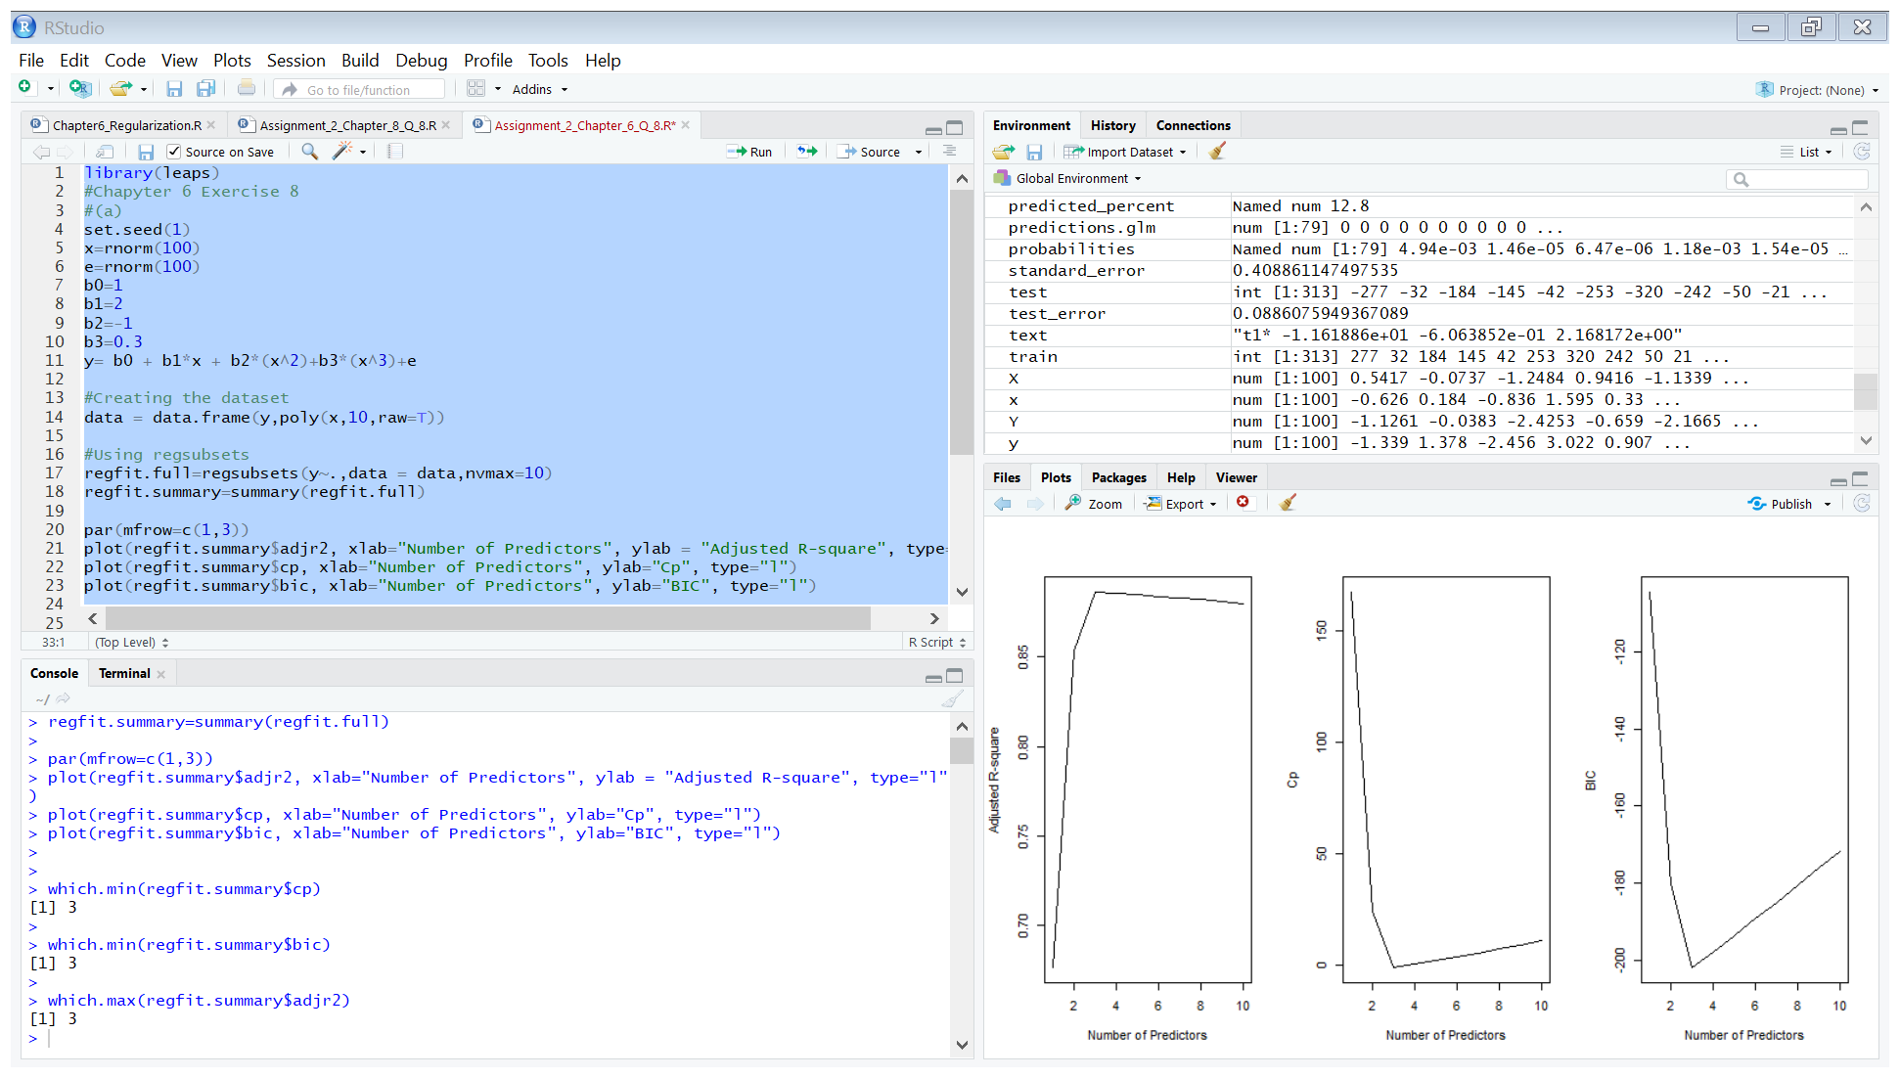

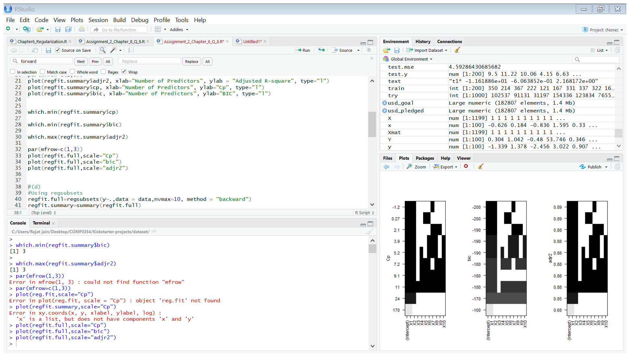

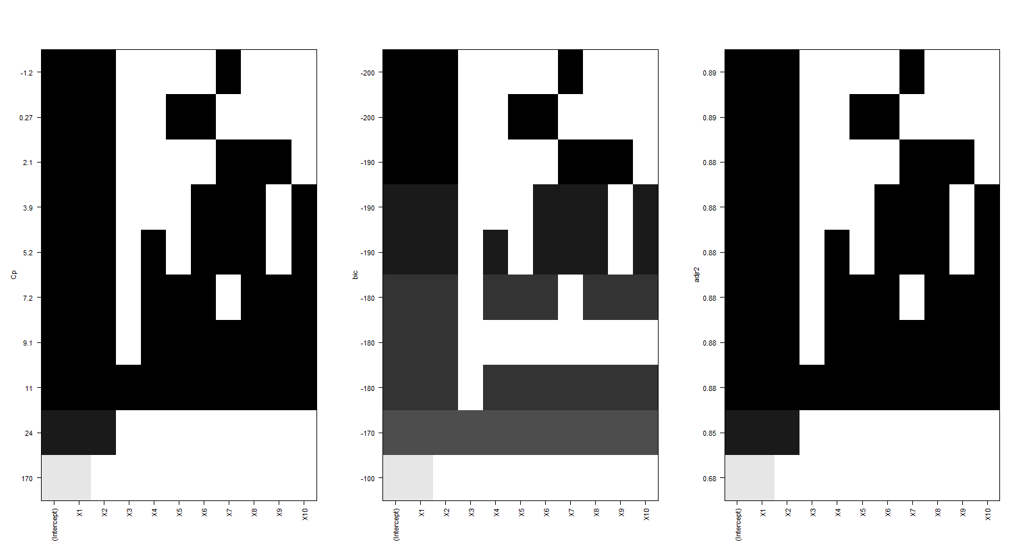

1. Using the forward subset selection method:

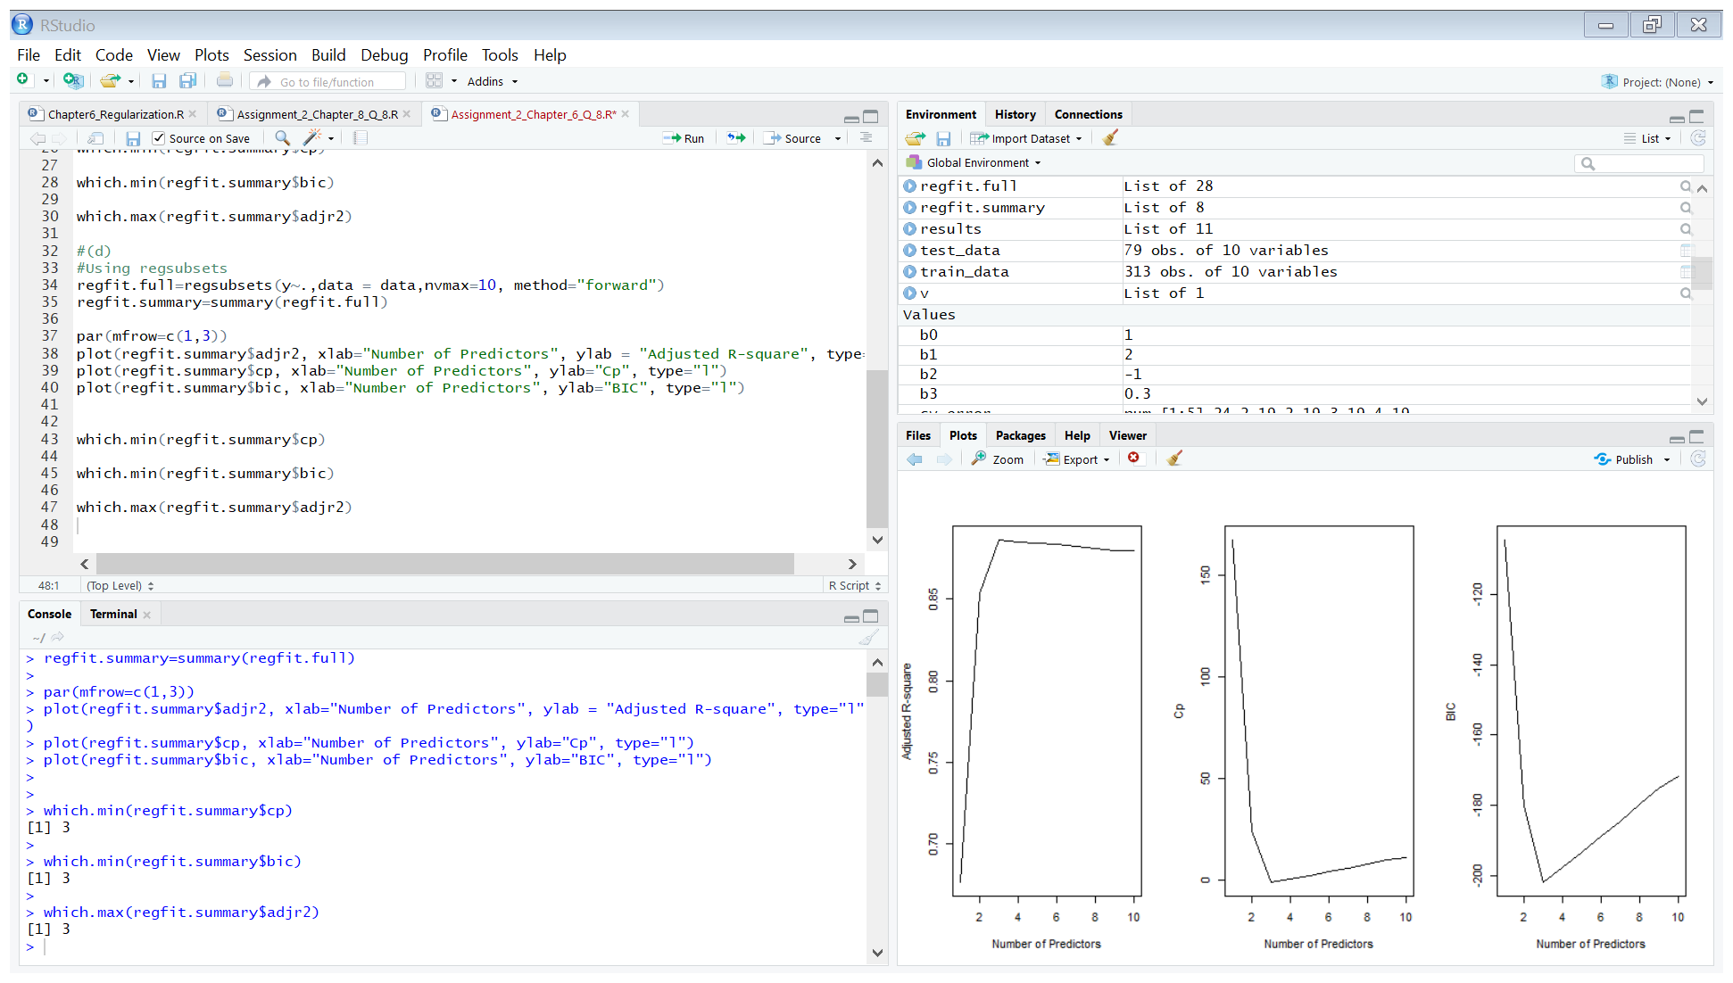



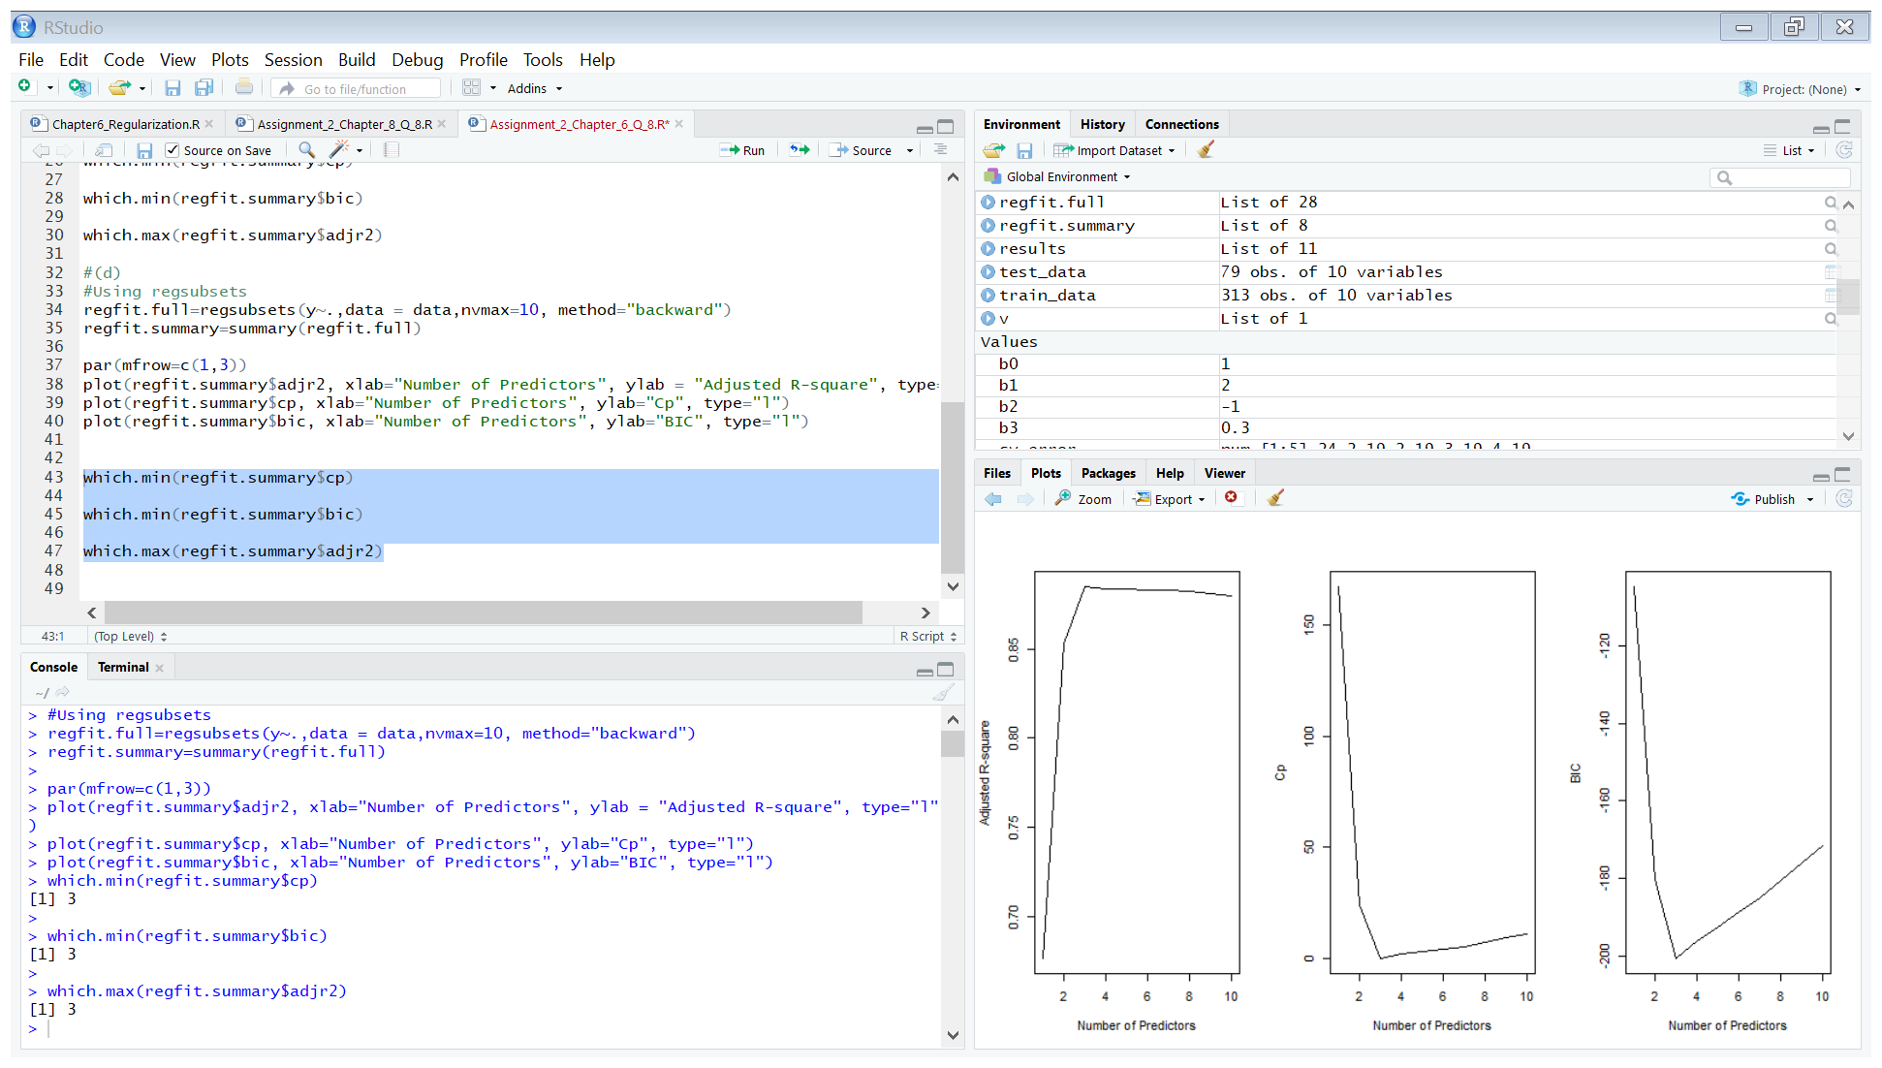

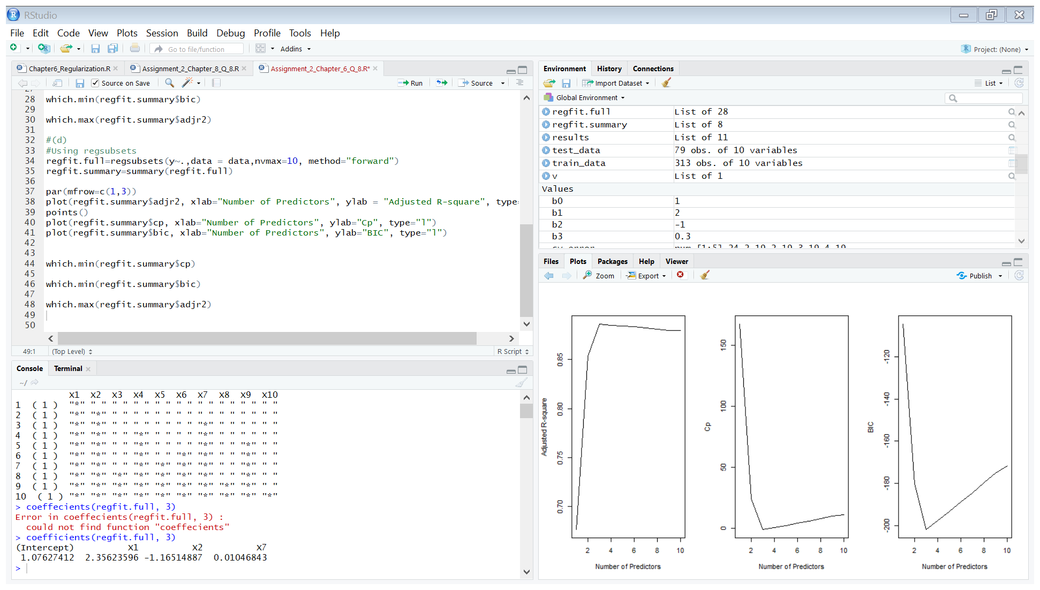

* The best model from forward selection involves x, x2 and x7.

Using the backward subset selection method:

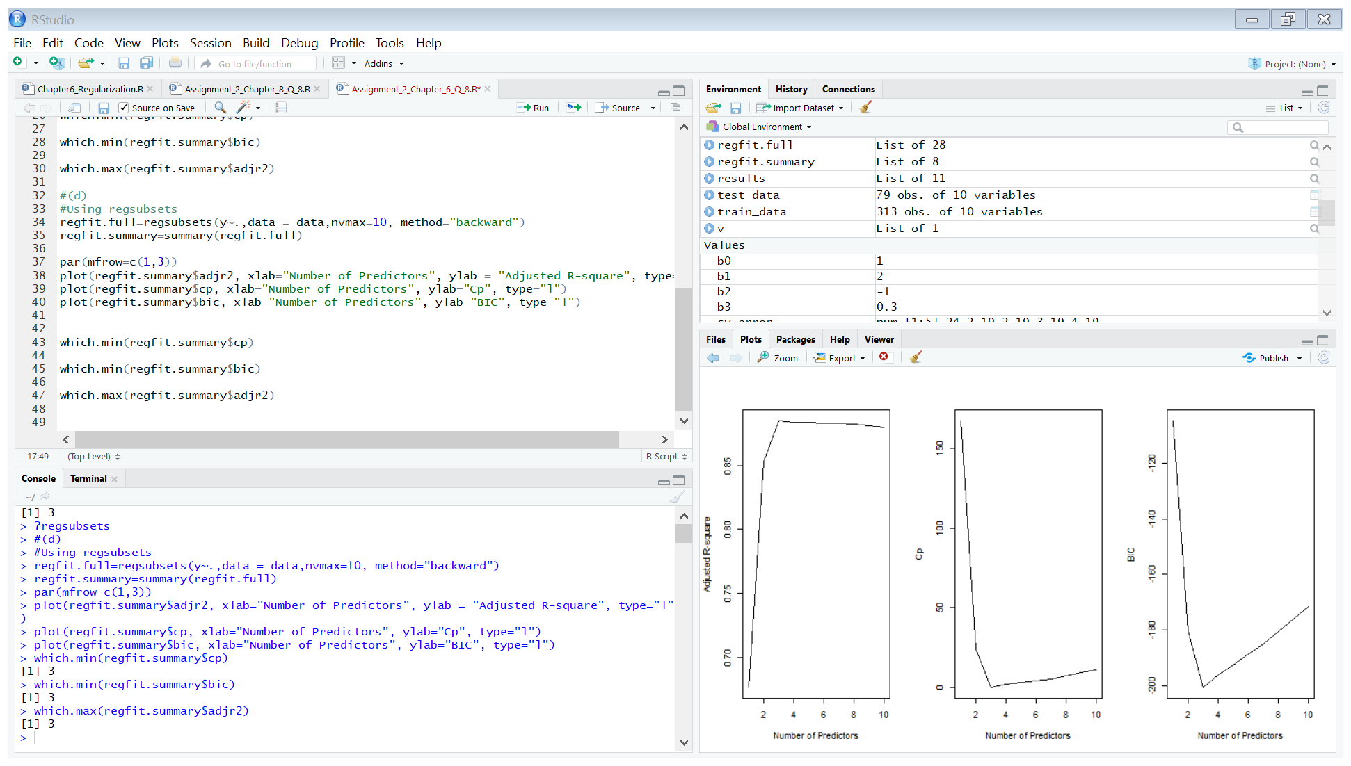

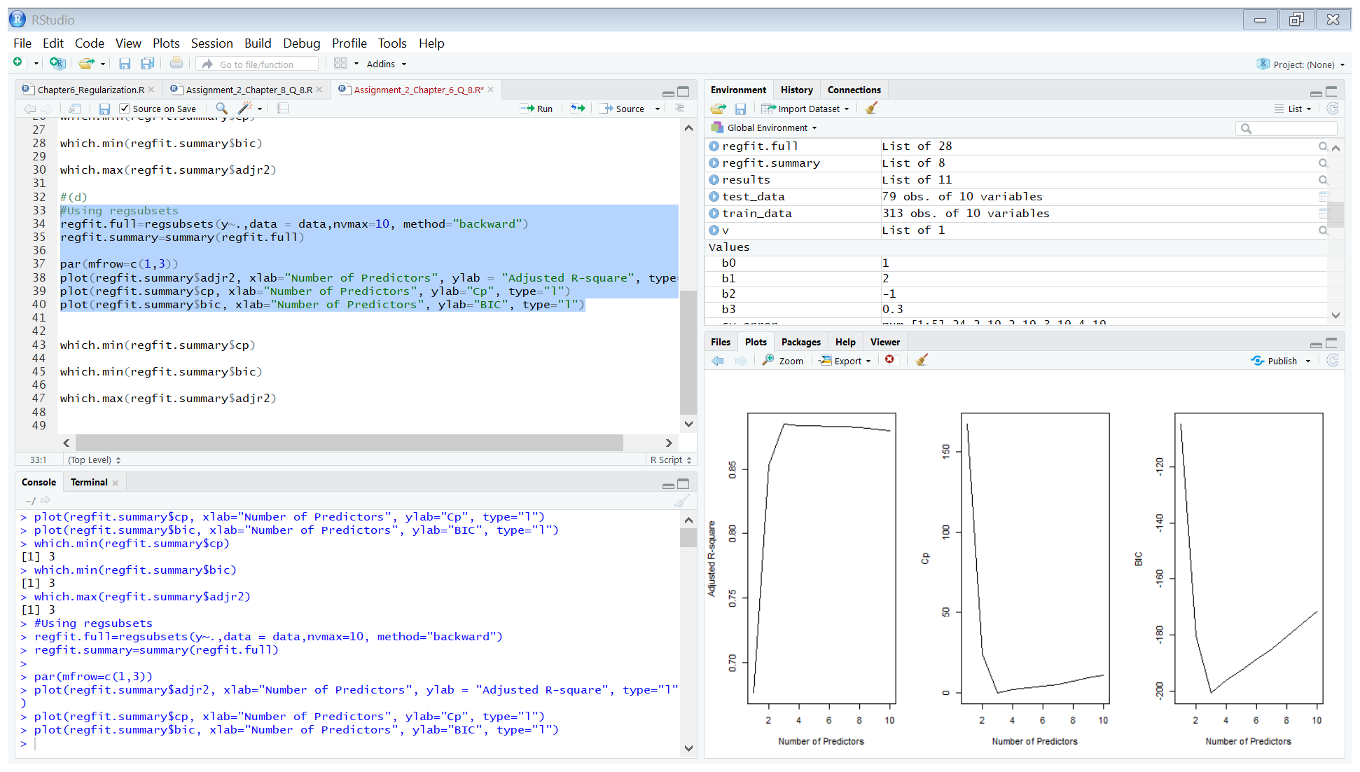



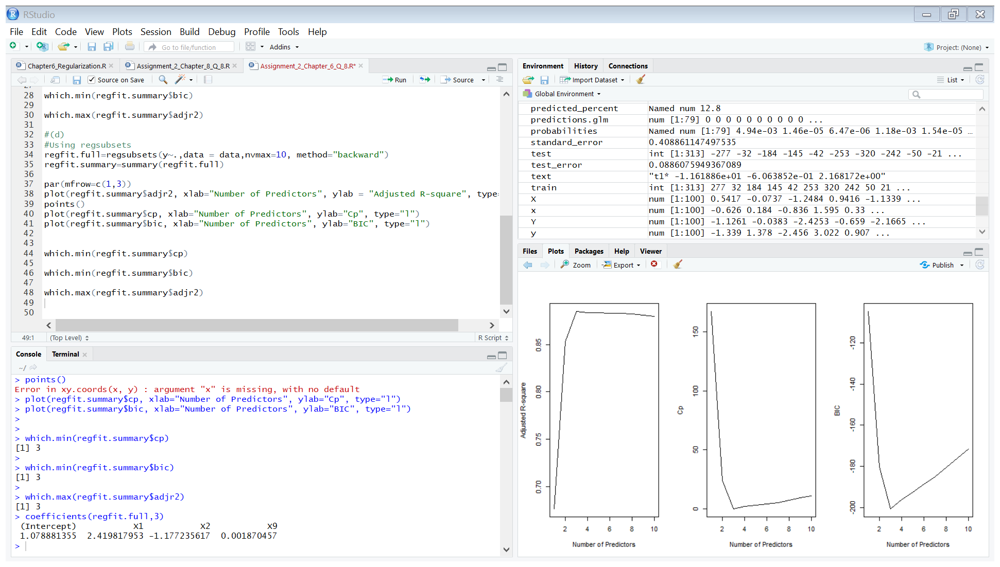

* The best model from backward selection involves 3 variables, x, x2 and x9. However the coefficient of x9 is not significant.

The results from forward and backward selection also involve 3 predictor variables. However, in case of backward selection x9 is selected instead of x7.

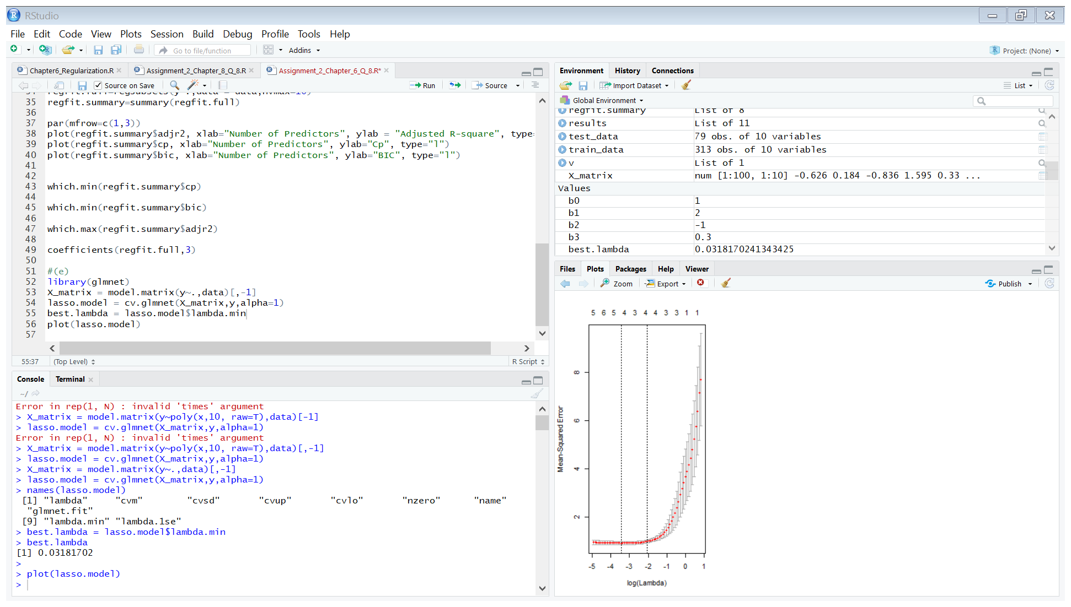

The best value of lambda obtained from cross-validation approach is 0.03181702.

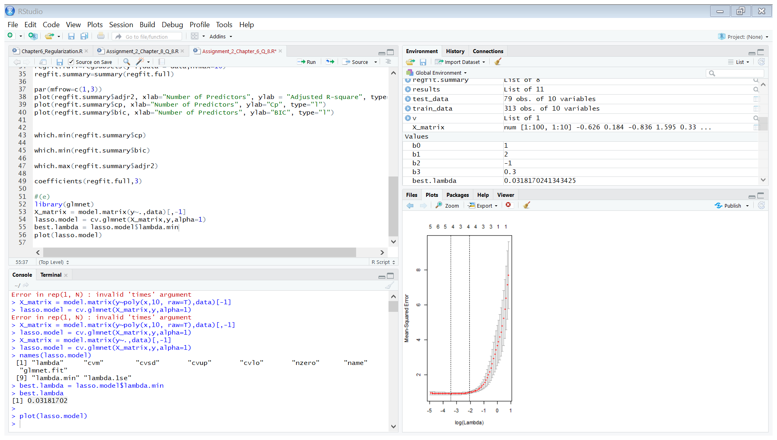

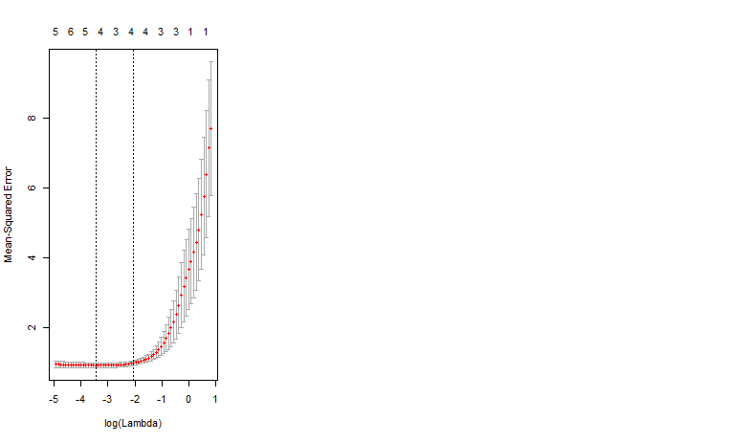

Plot of cross validation error as a function of lambda.

Now, we will fit the model on the training data on the basis of the value of lambda obtained from cross validation.

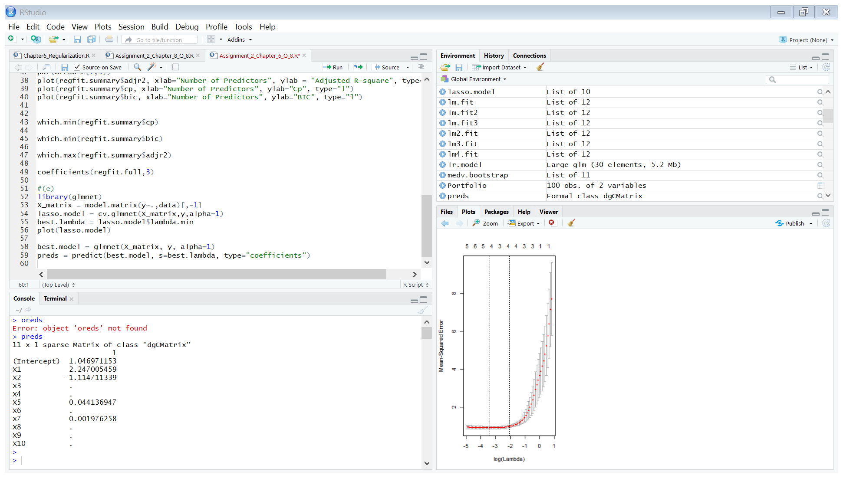



* The best model from lasso regression selects only x, x2,x5 and x7. However the coeffecients if x5 and x7 are not significant.

(f)

Applying Best Subset Selection:

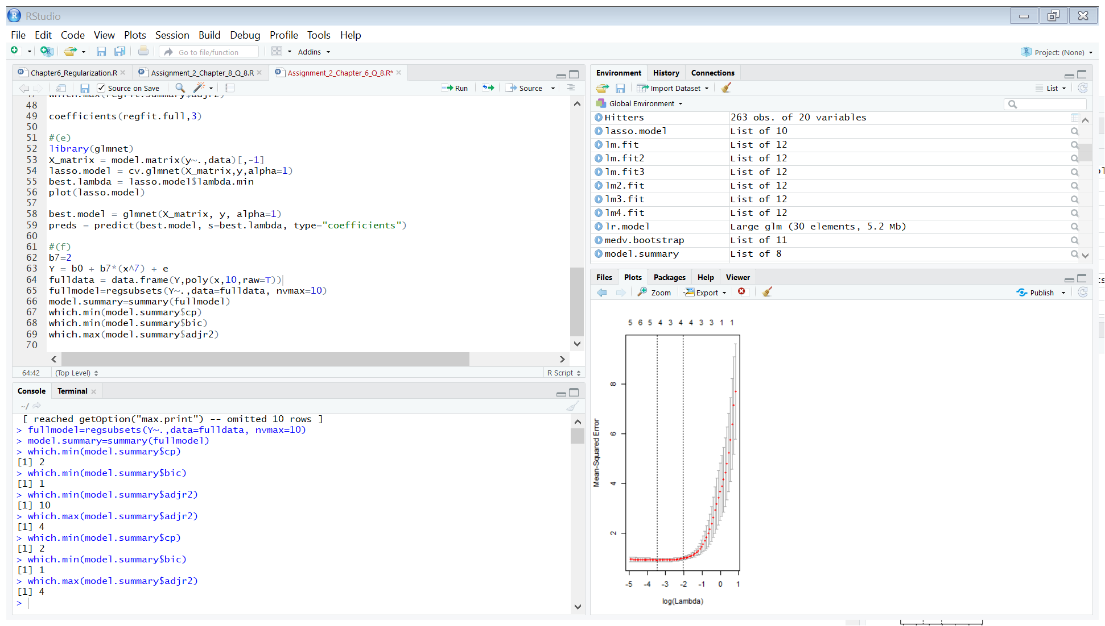

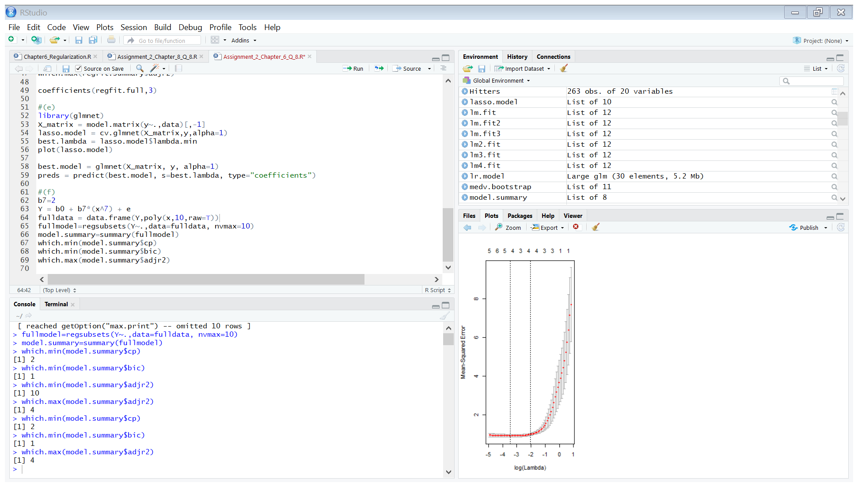

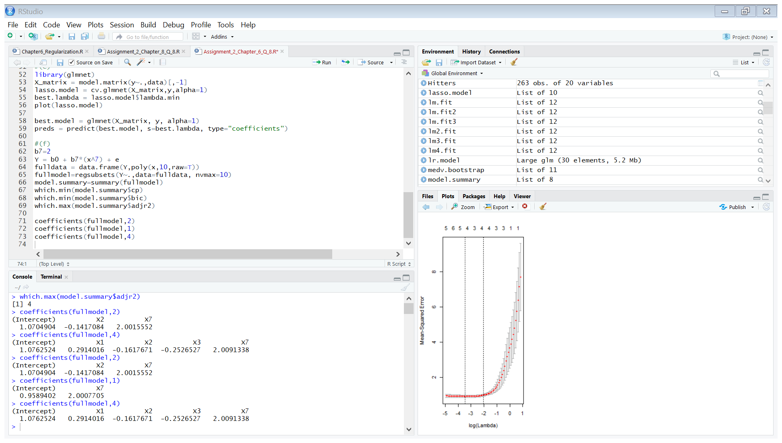

* It can be observed that BIC picks the most accurate 1 variable model which is very close to the real model as the coefficient estimate is very close to the real one as well as the intercept. Adjusted R-square and Cp methods pick additional unnecessary variables.

Applying Lasso:

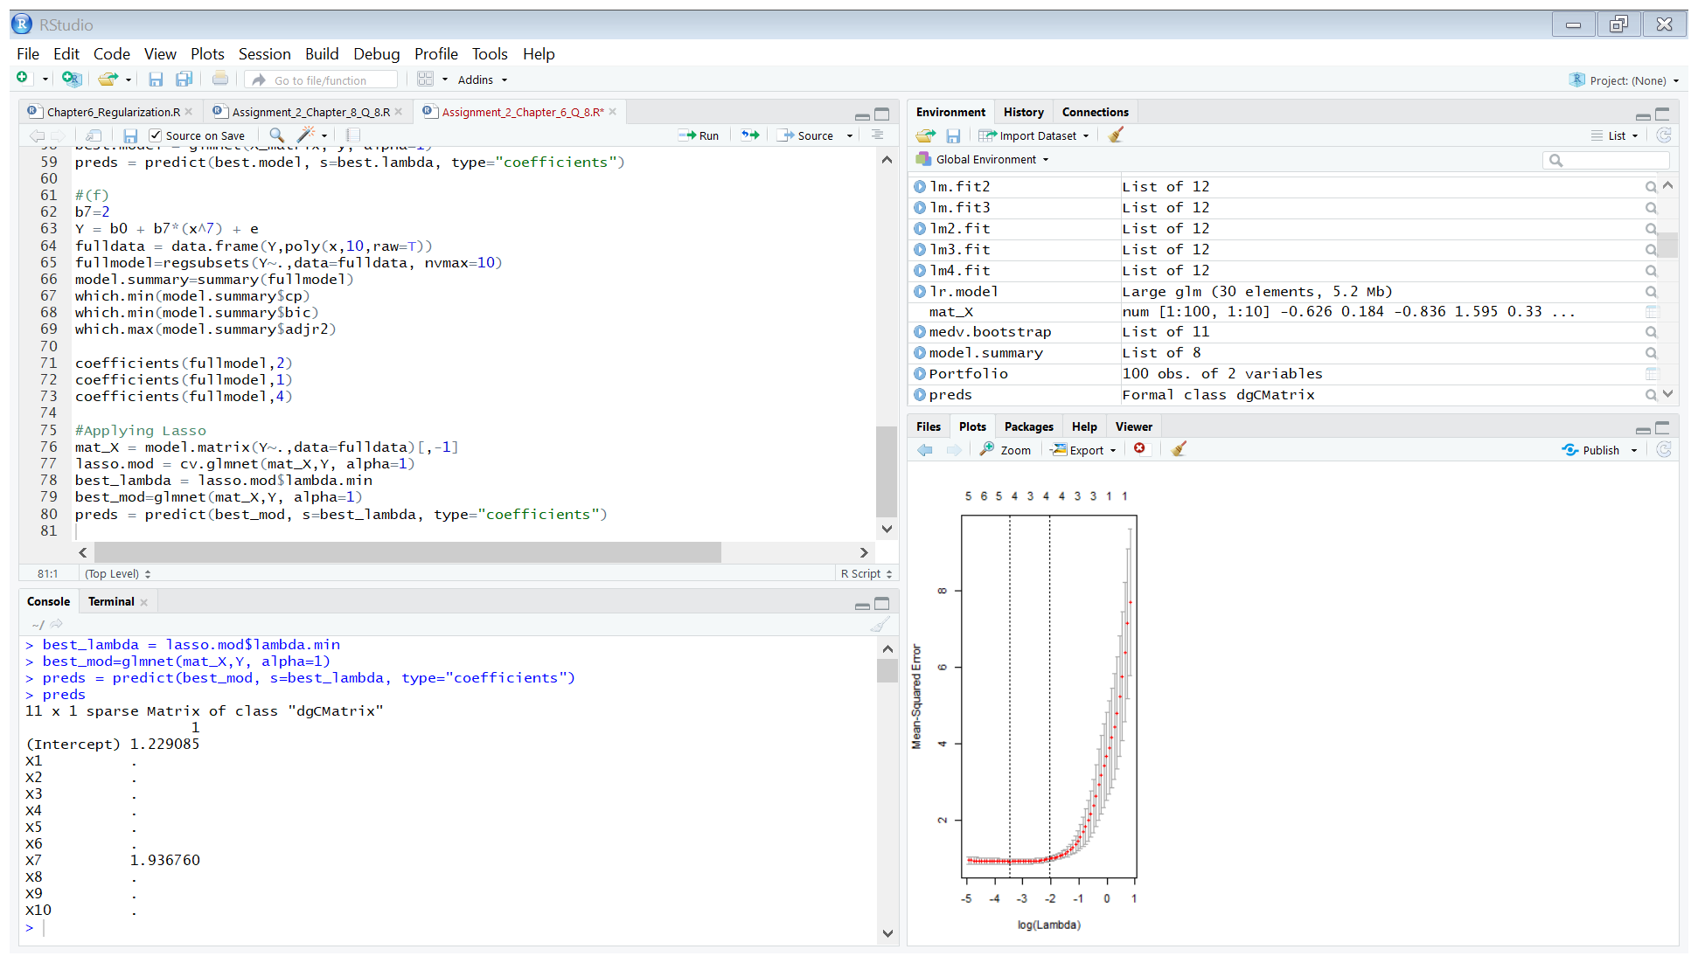

Results:

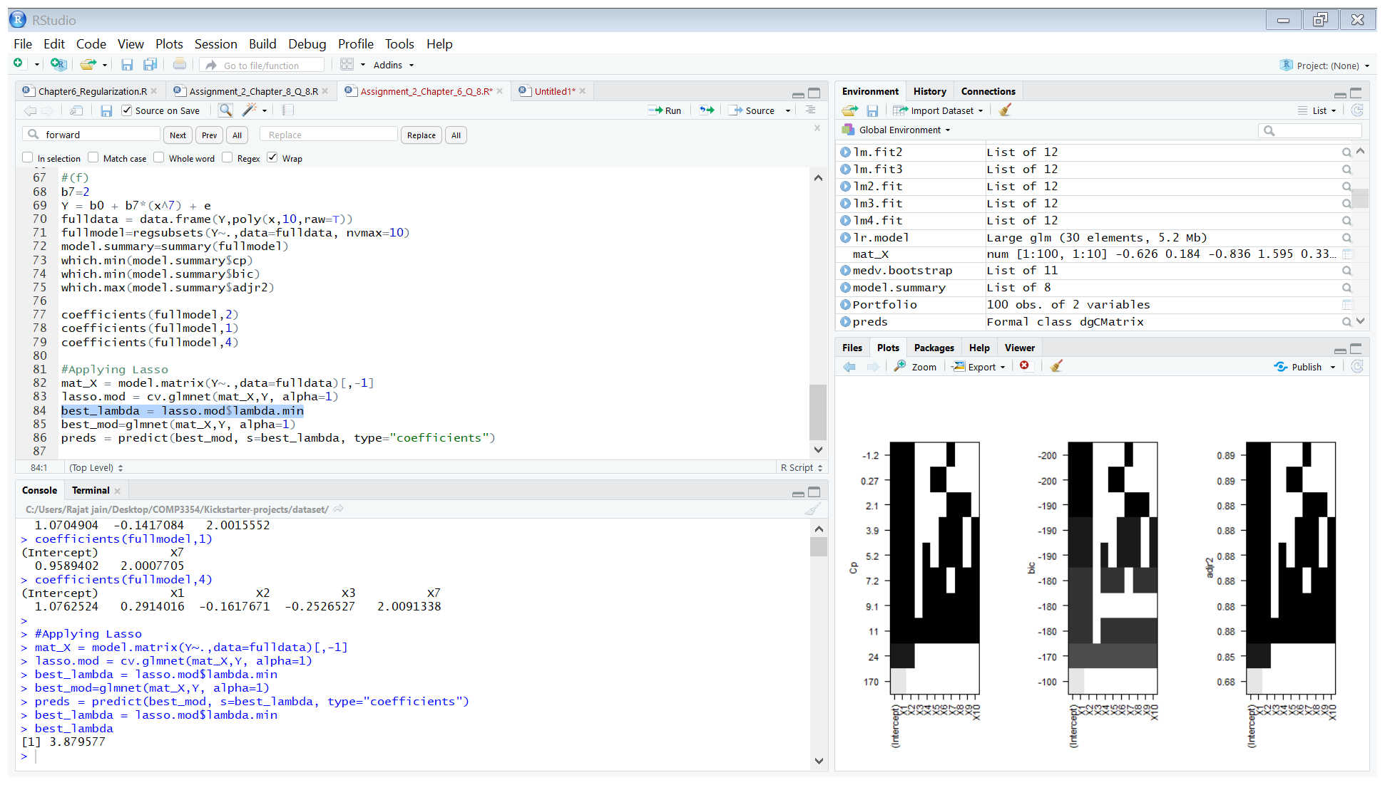

The best value of lambda chosen by the lasso model is 3.879577.



The lasso method selects only one predictor variable which is the one which exists in the real model, furthermore the estimated coeffecients are close to the real coeffecients. Hence the model which results from lasso regression is a very close estimation of the real model.

Chapter 8 Exercise:

Question 8.

1. Splitting the data into training and testing data.

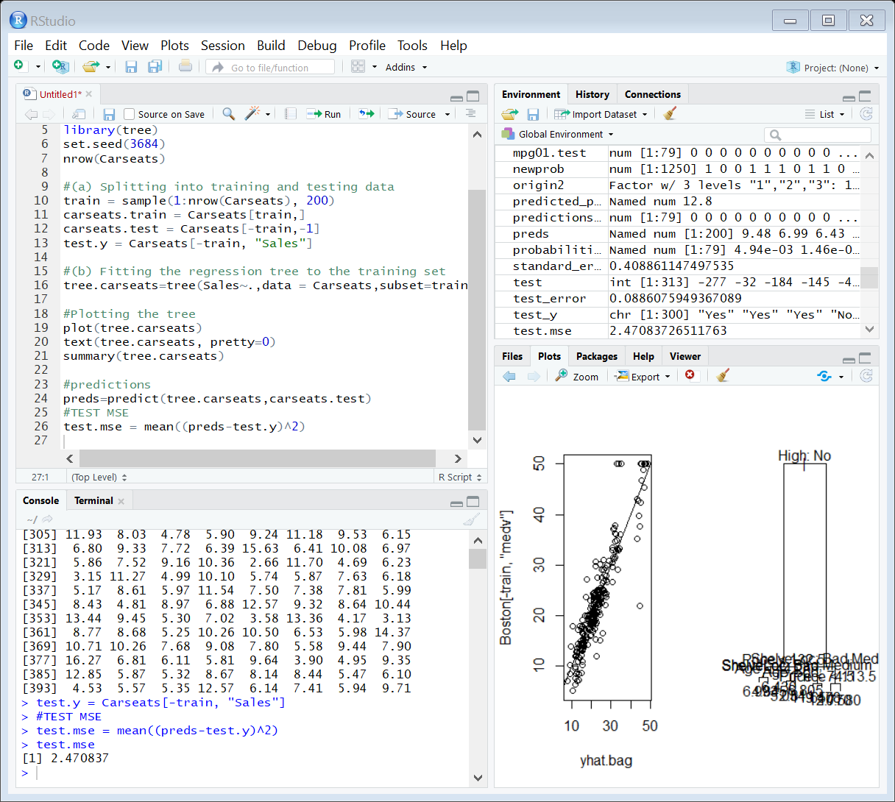

1. Fitting a regression tree to the training set and plotting the tree.

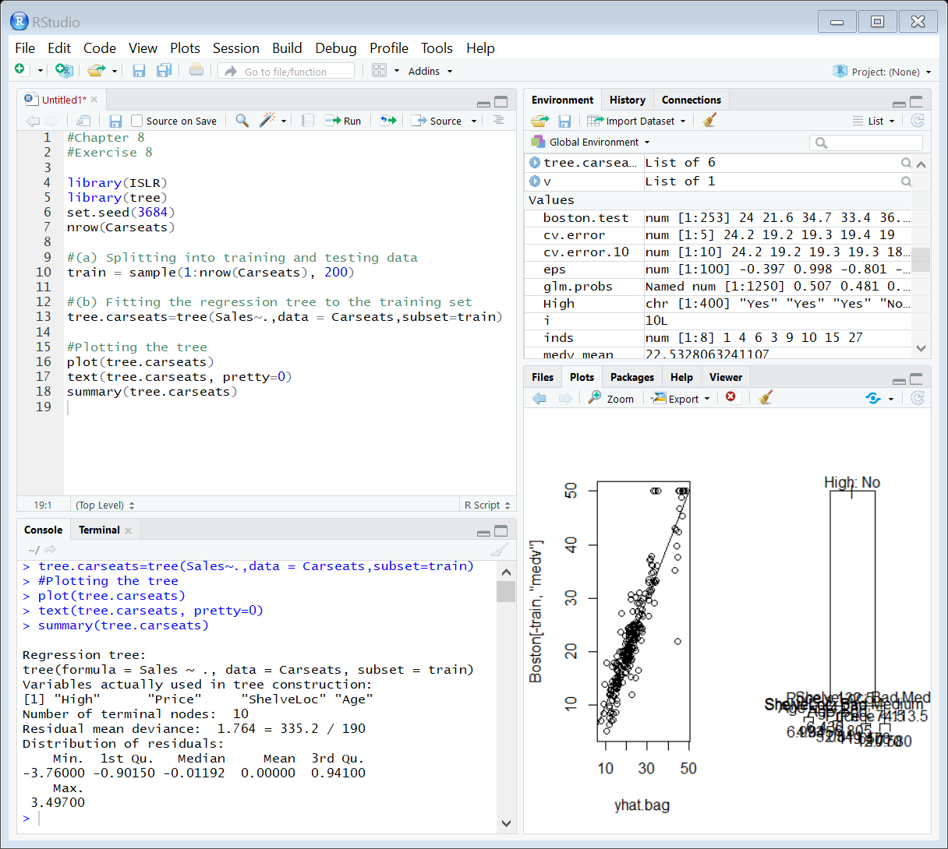

Resulting regression tree:

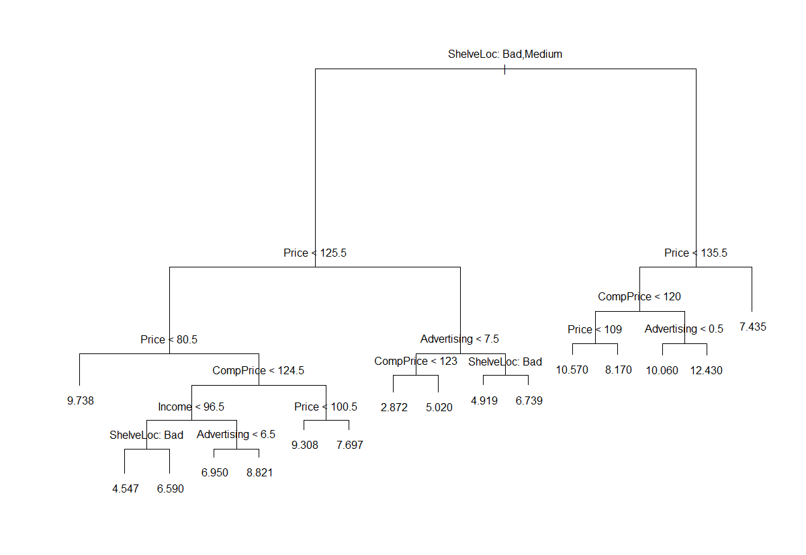

Summary of the regression tree:

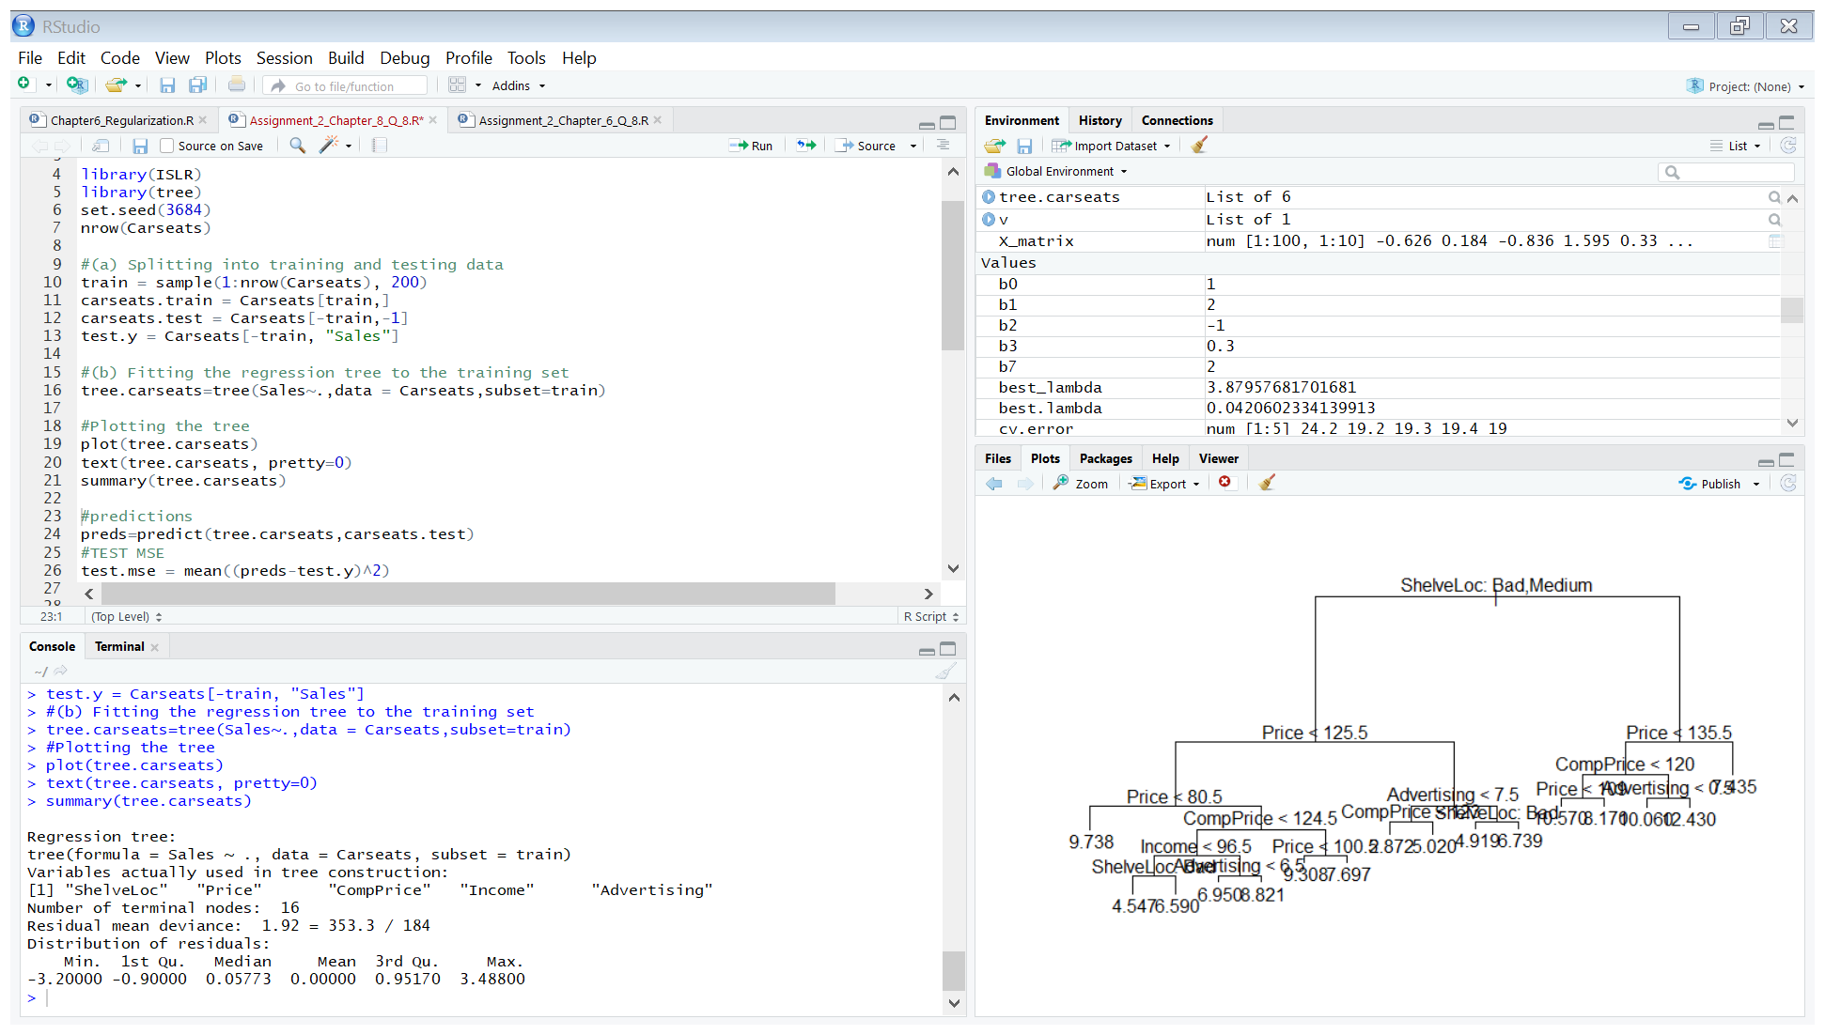

The regression tree has 16 terminal nodes.

Finding the test error:



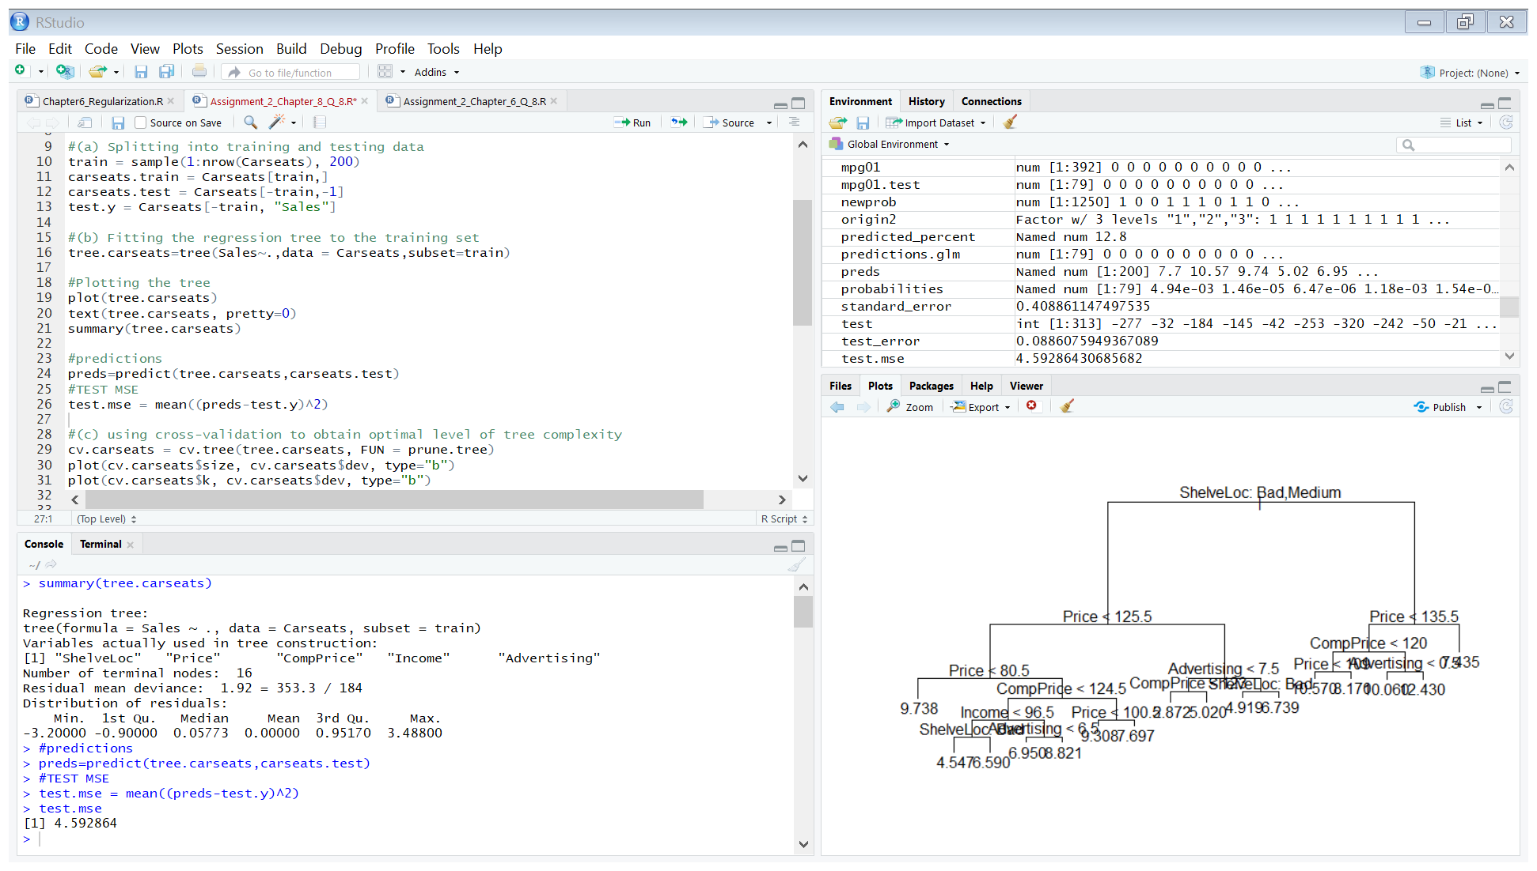

* The test error is 4.592864.

1. Using cross-validation to obtain optimal level of tree complexity.

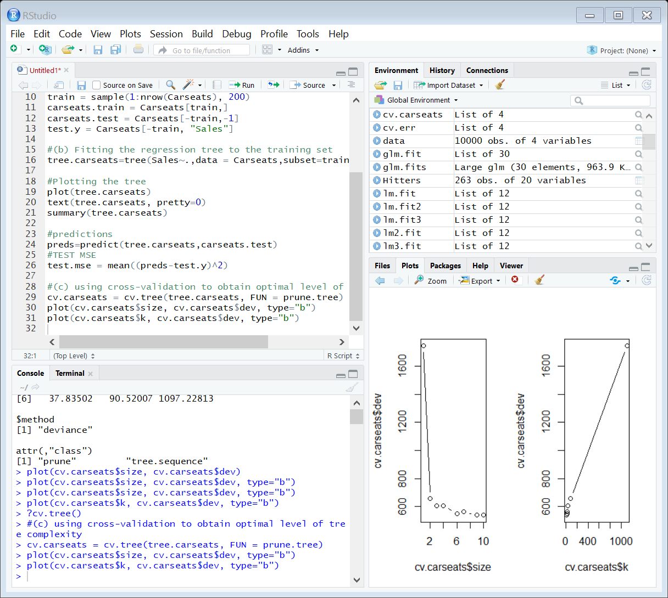

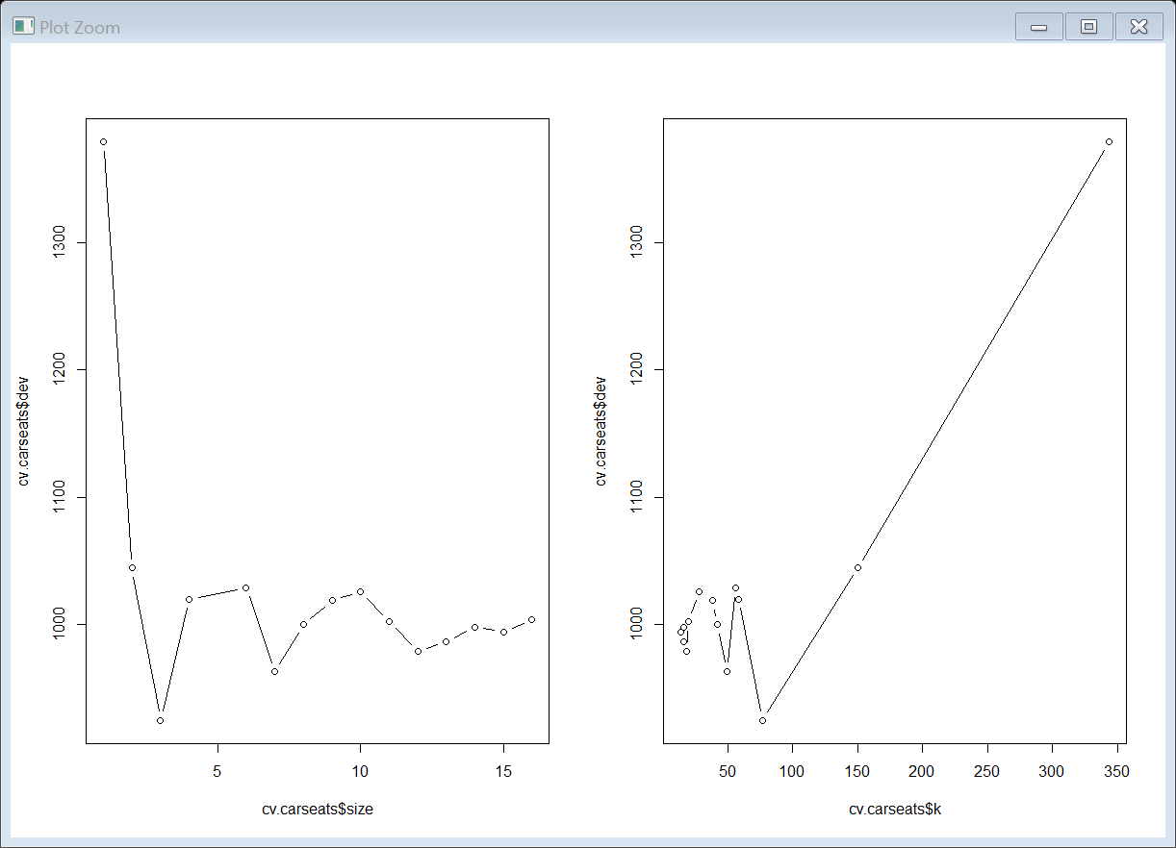

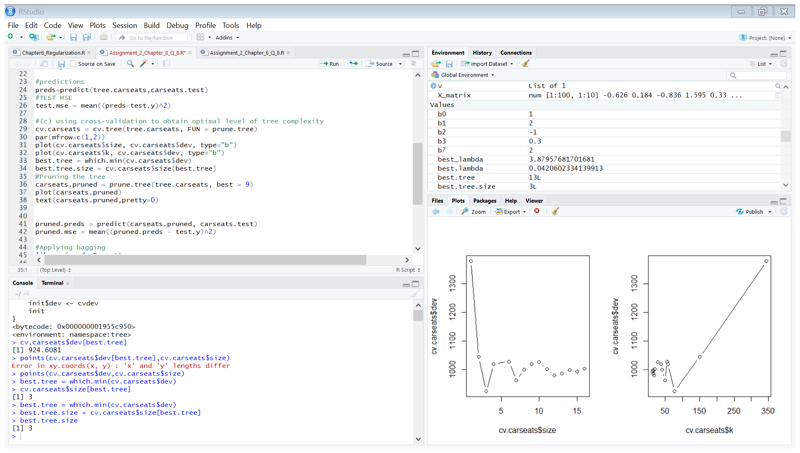

* Cross validation results in the tree of size 3.

Let us prune the tree according to the best tree size given by cross validation and calculate the test MSE.

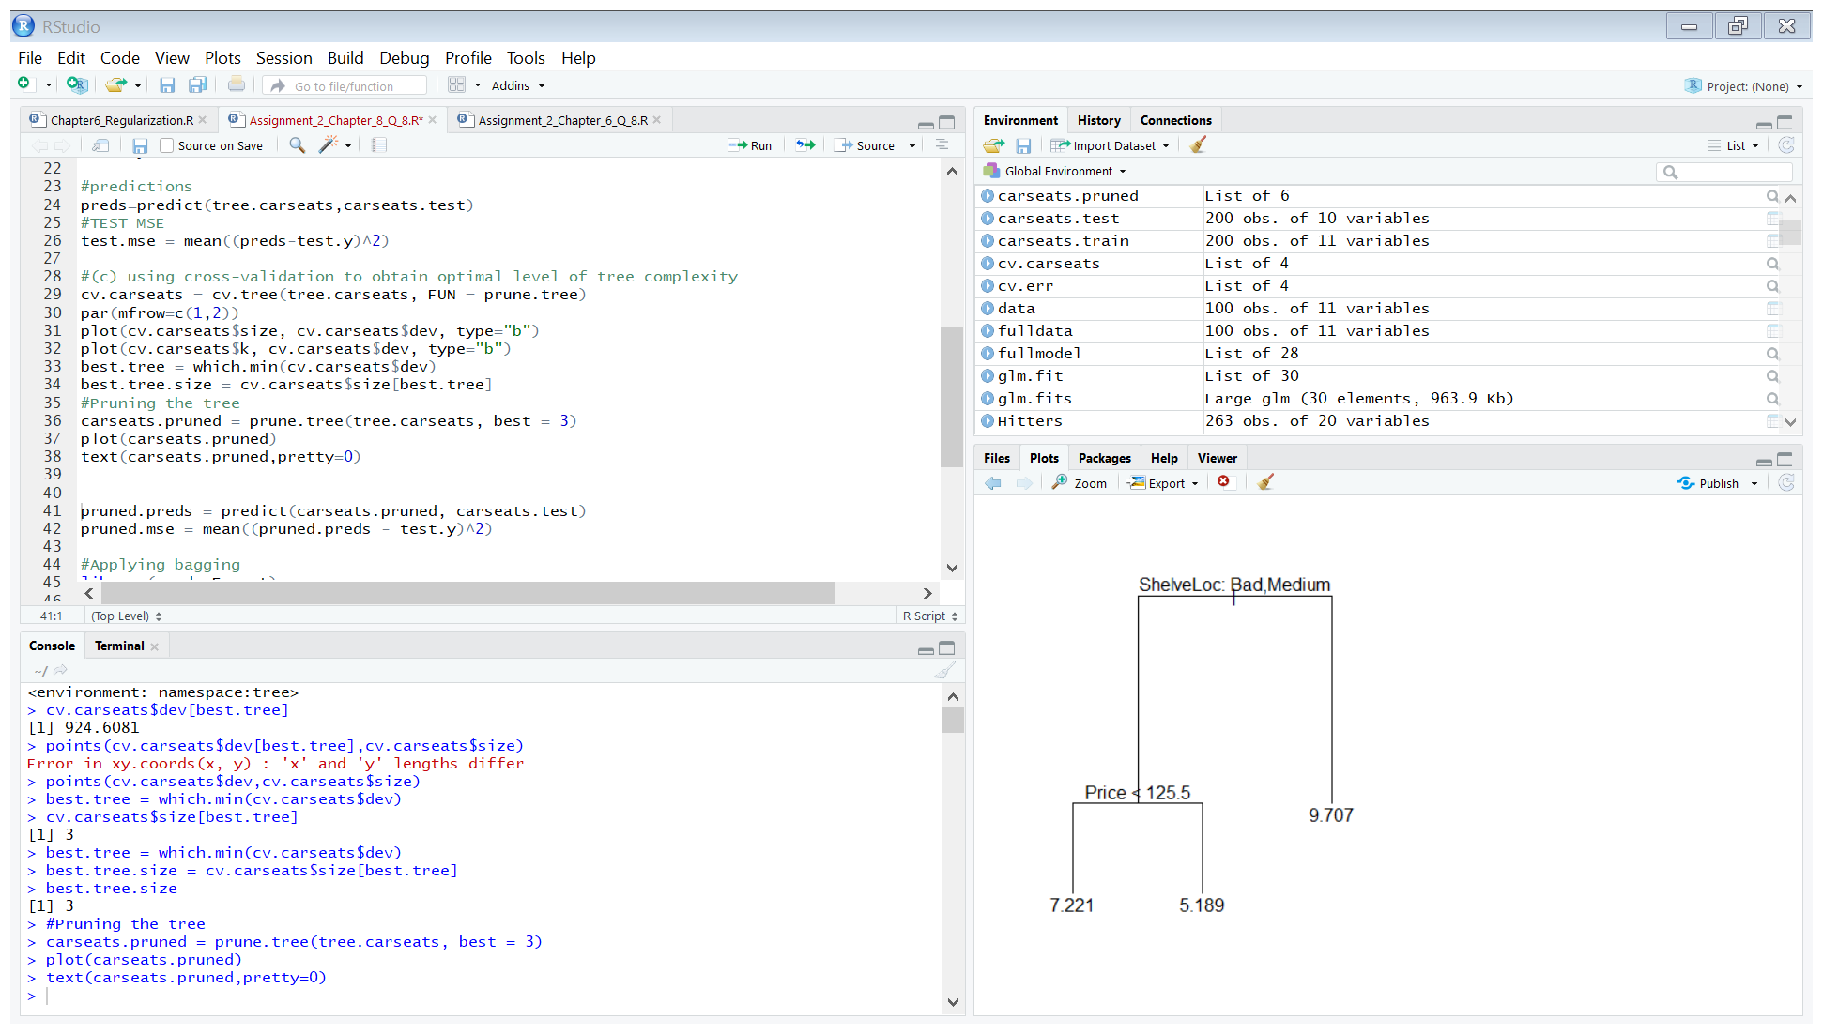

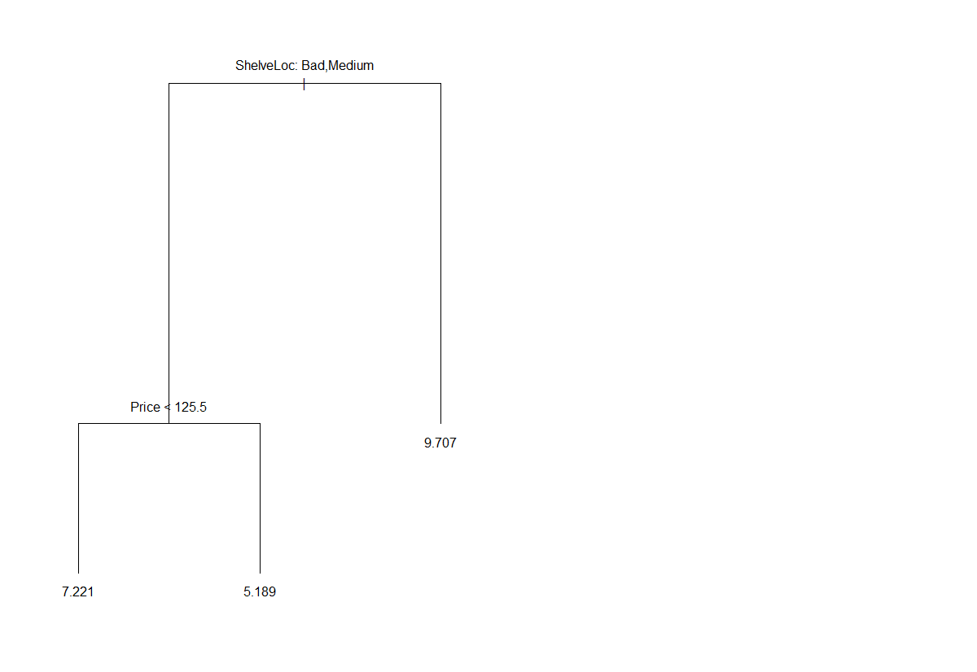

Calculating test MSE on the pruned tree:

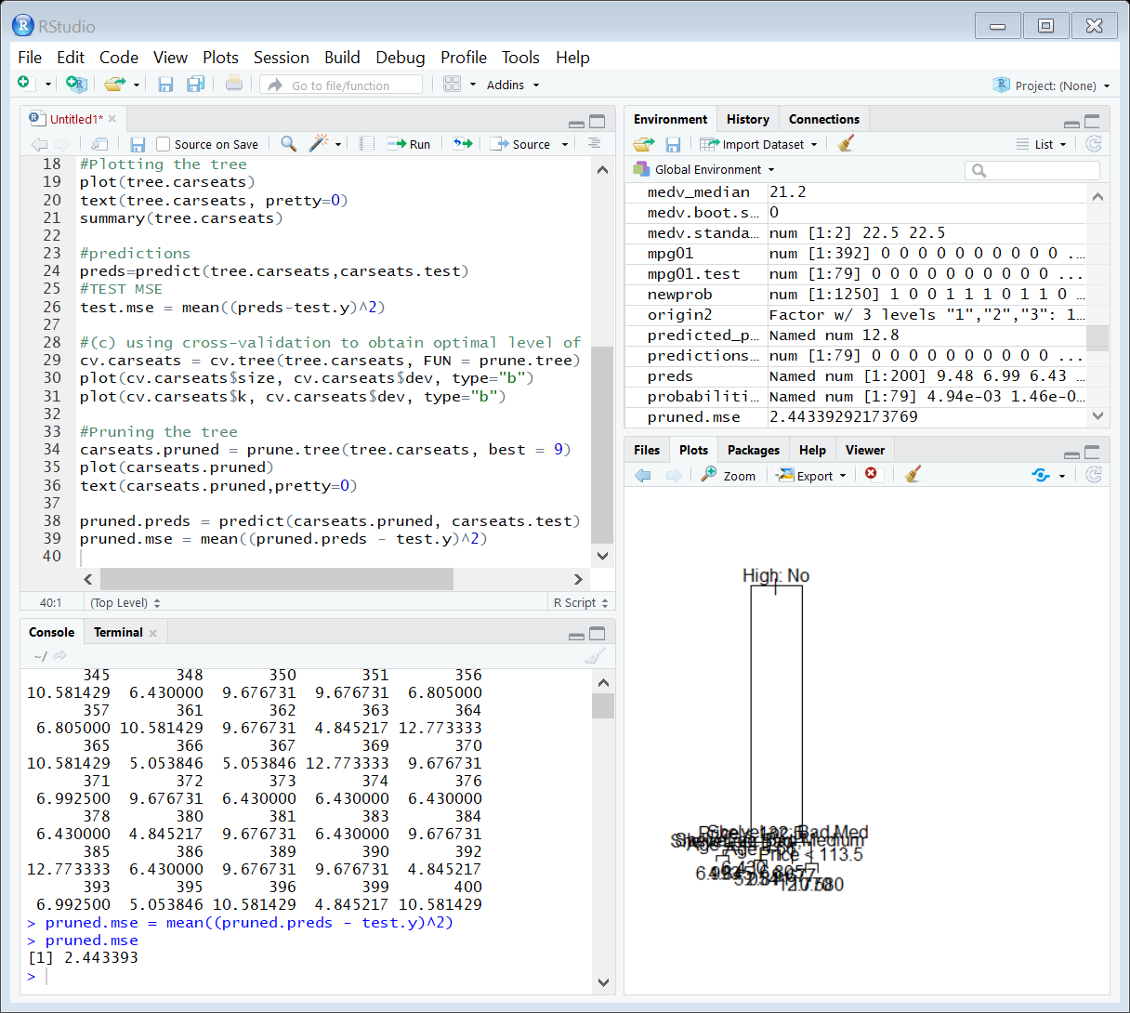

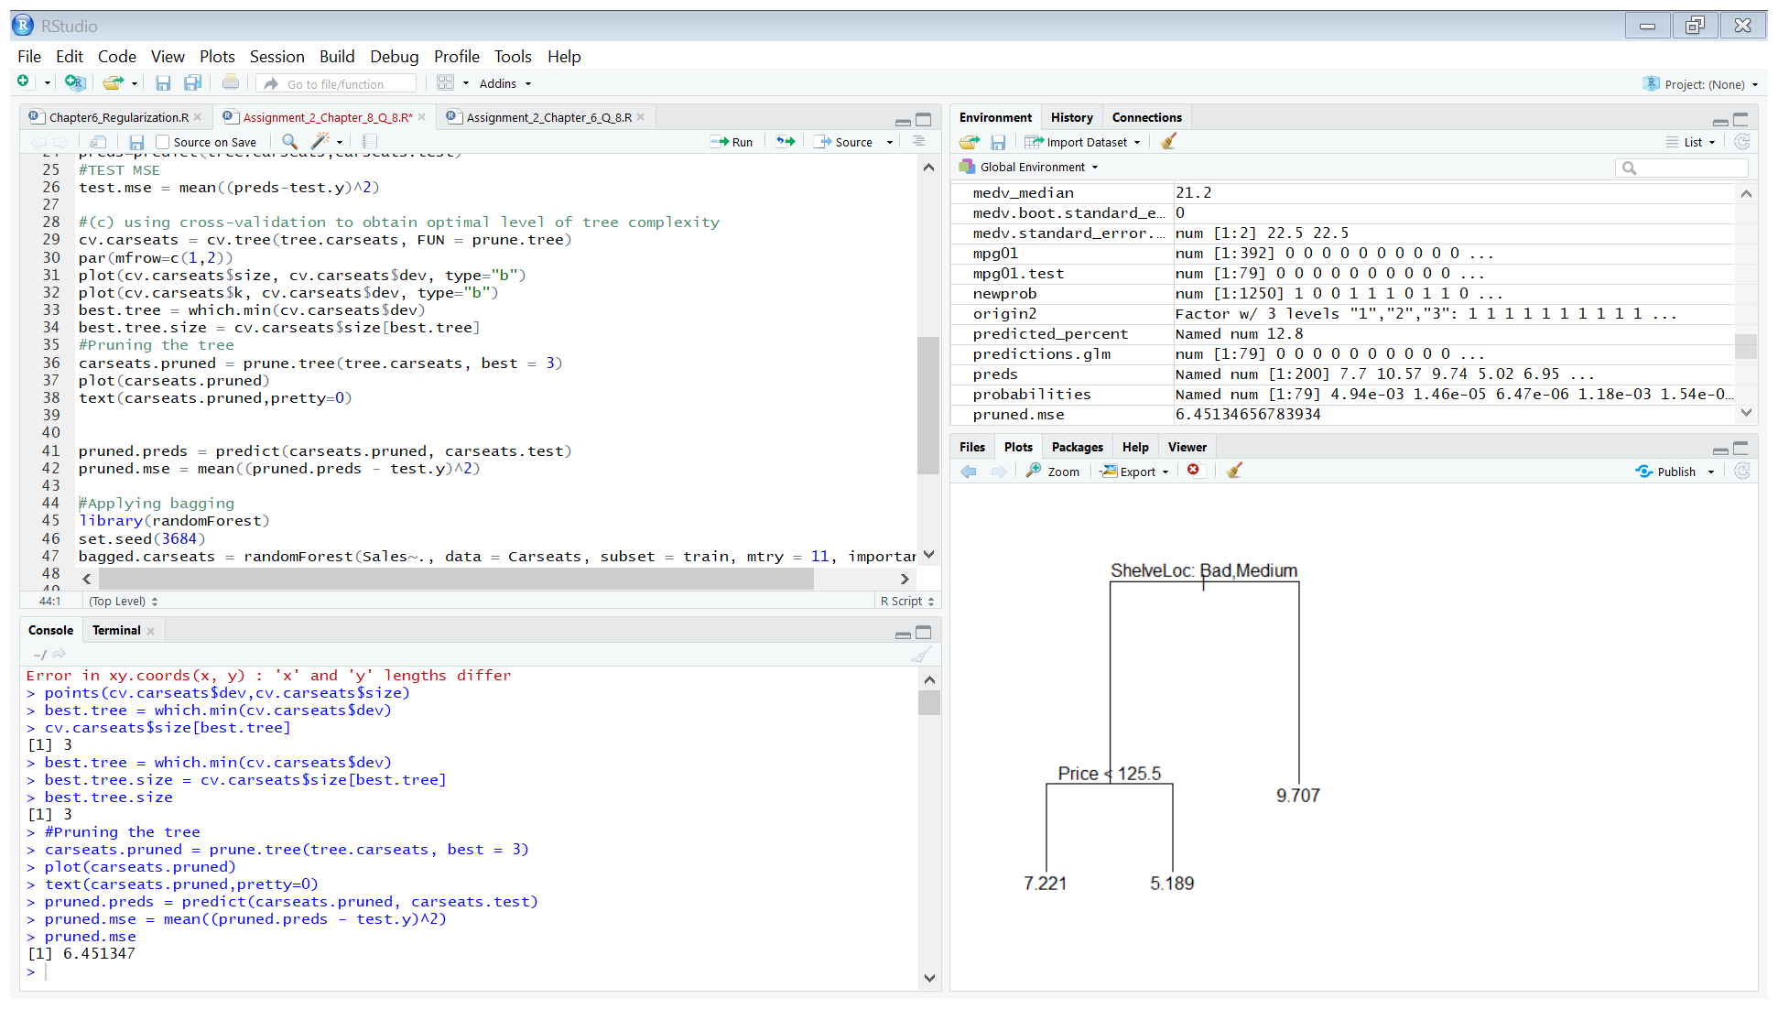

The test MSE on the pruned tree is 6.451347 which is higher than the test MSE of the non-pruned tree.

1. Using the bagging approach to analyse the data and calculating test MSE.

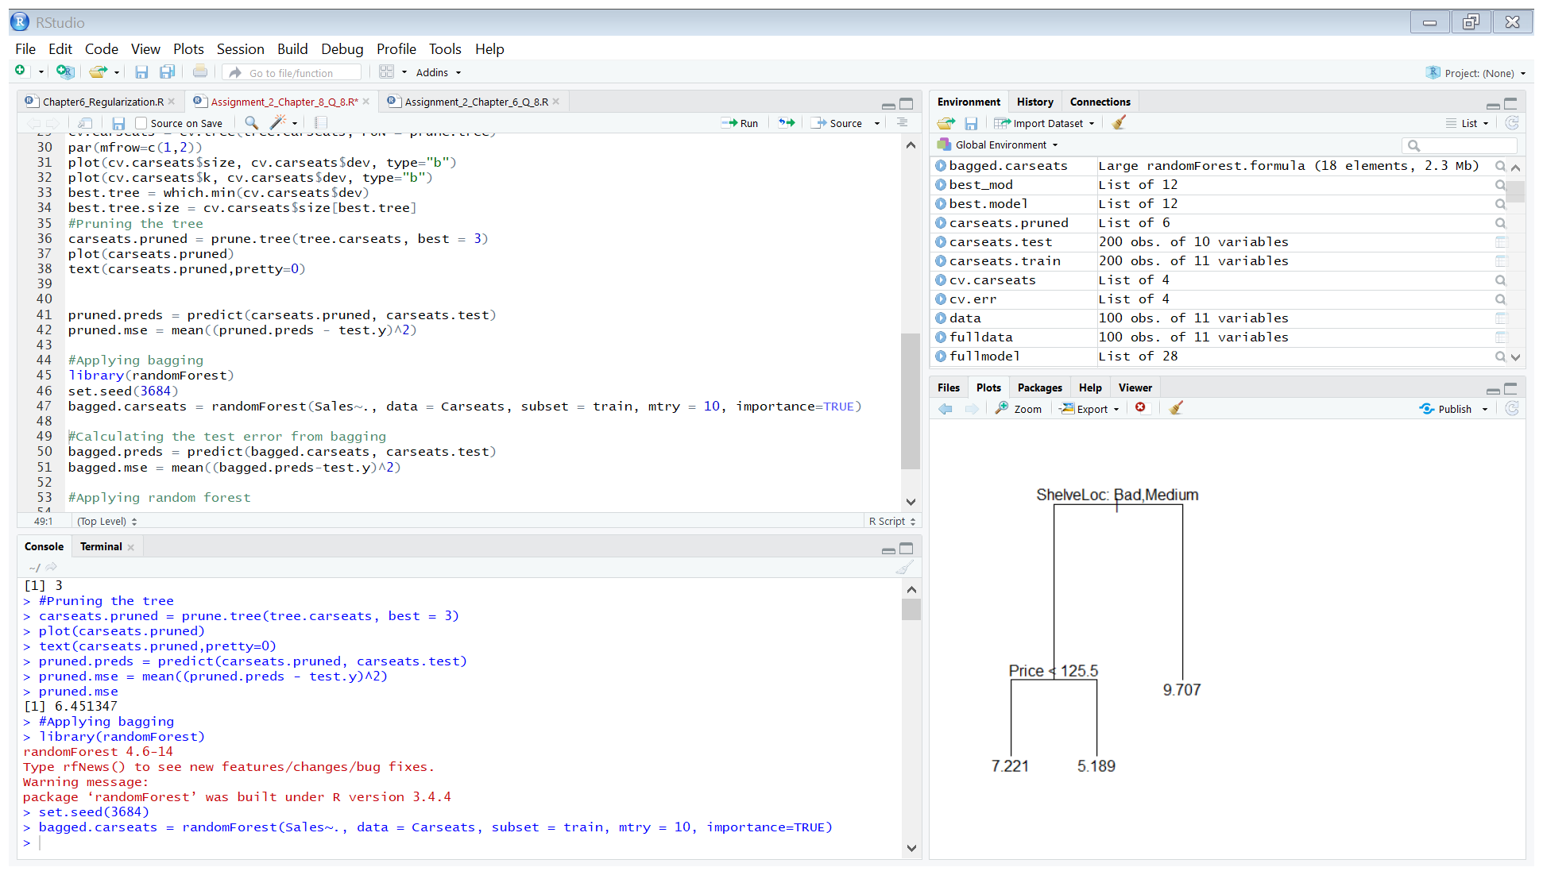

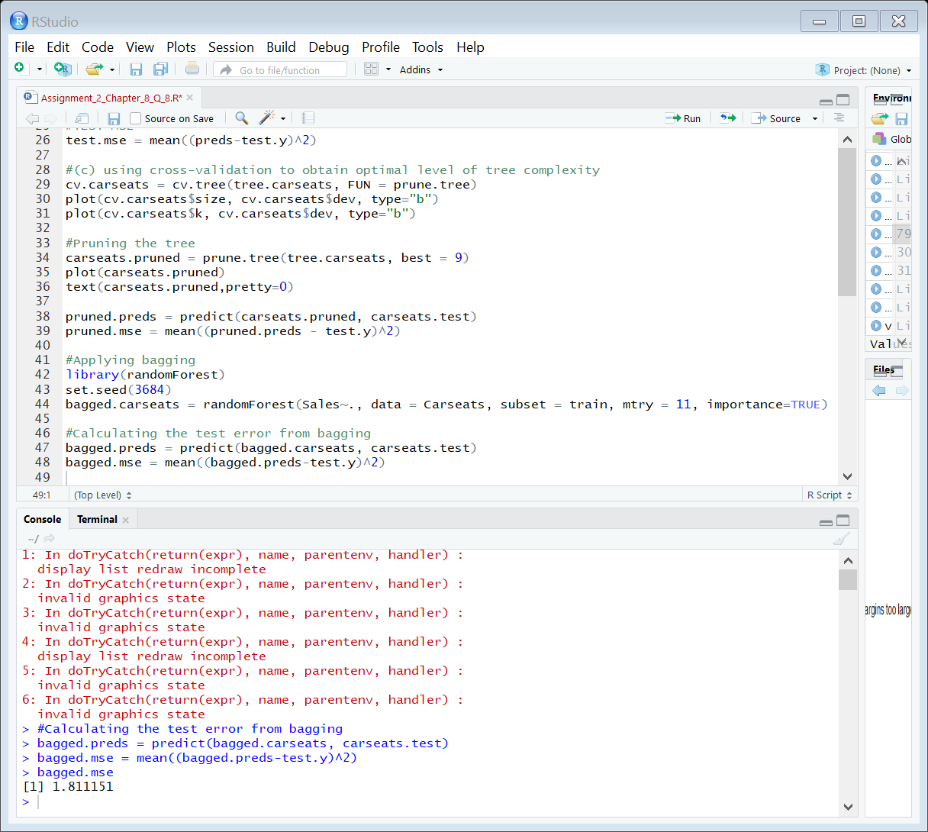

Result:

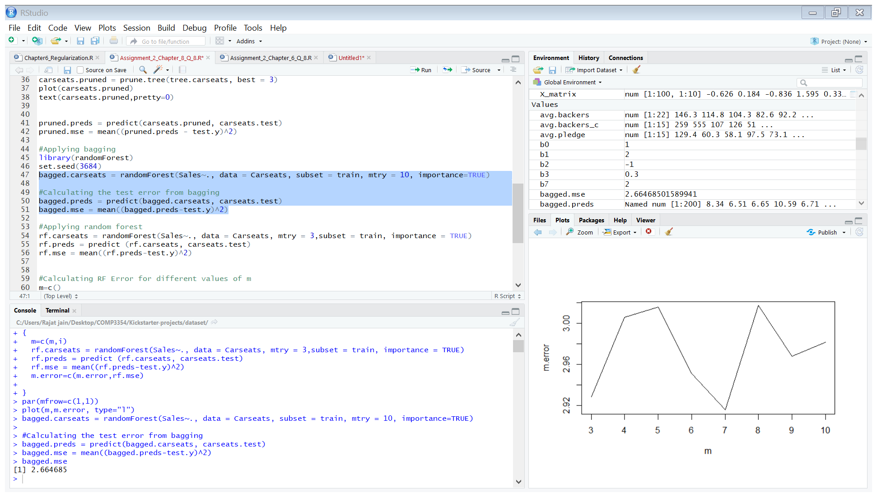

* The resulting test error from bagging is 2.664685, which is significantly lower as compared to the test error from the original and pruned tree.

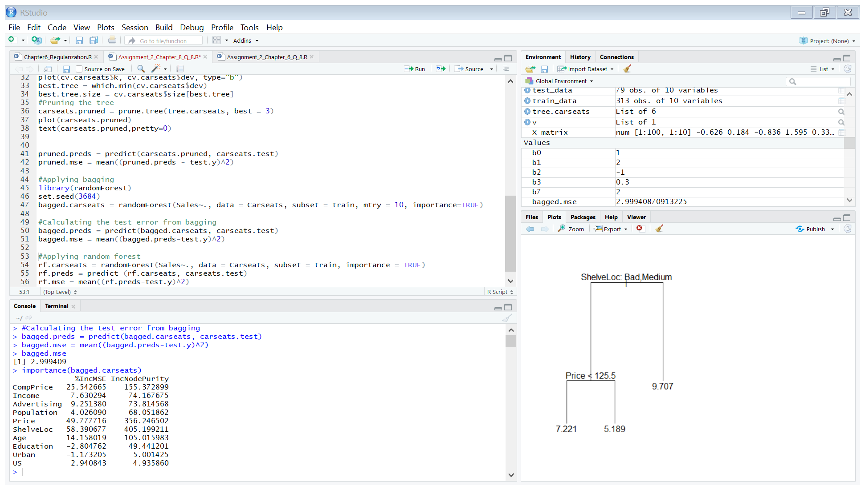

* The most important predictors of sale are ShelveLoc, Price and CompPrice.

1. Using random forest to analyse the data and calculating test MSE.

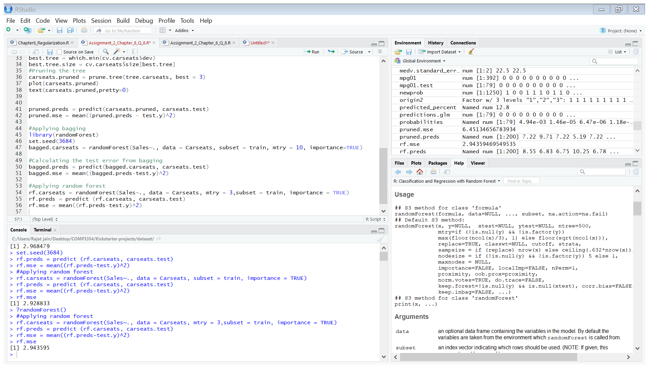

Resulting test MSE:



* The resulting test error from random forest method is 2.943595.
* The cross validation error resulting from random forest is higher than the cross validation error resulting from bagging.
* When we used the bagging approach, the number of variables tried, ‘m’ is 10 and the error rate is 2.664685 and when we use the random forest technique, where the value of ‘m’ is set to 3 (as $\sqrt{10}≈3$), the error rate is 2.943595. Hence the error rate increases as the value of m is decreased from 10 to 3.

Running random forest with m=3 and 10 5 times. In each iteration, the error for m=3 is higher than the error for m=10.

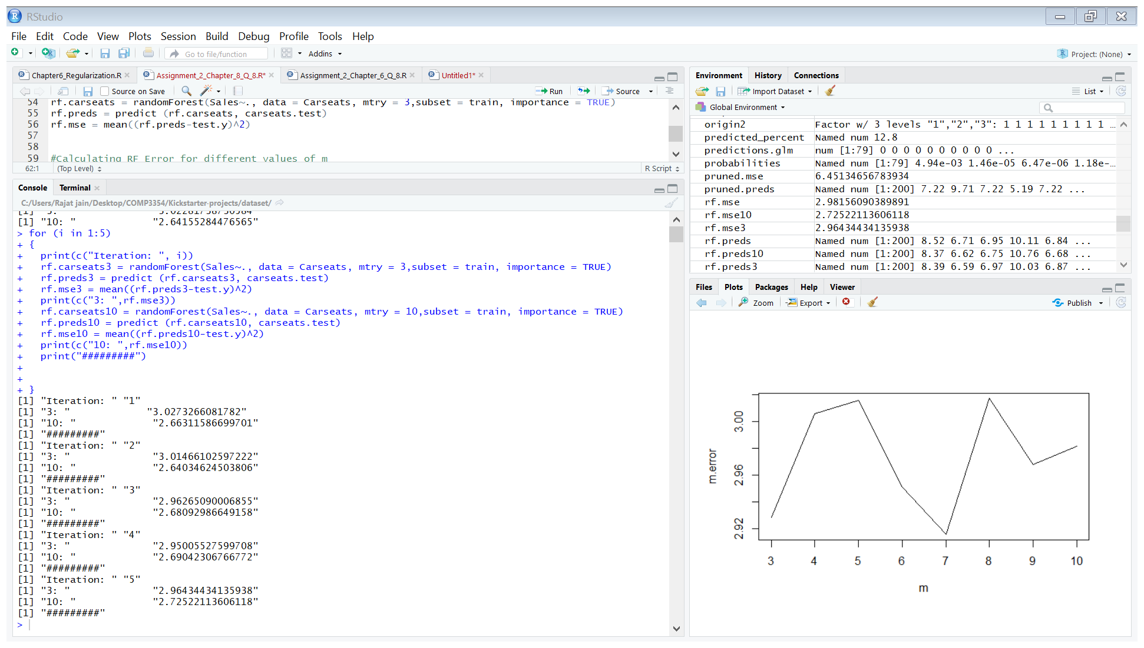

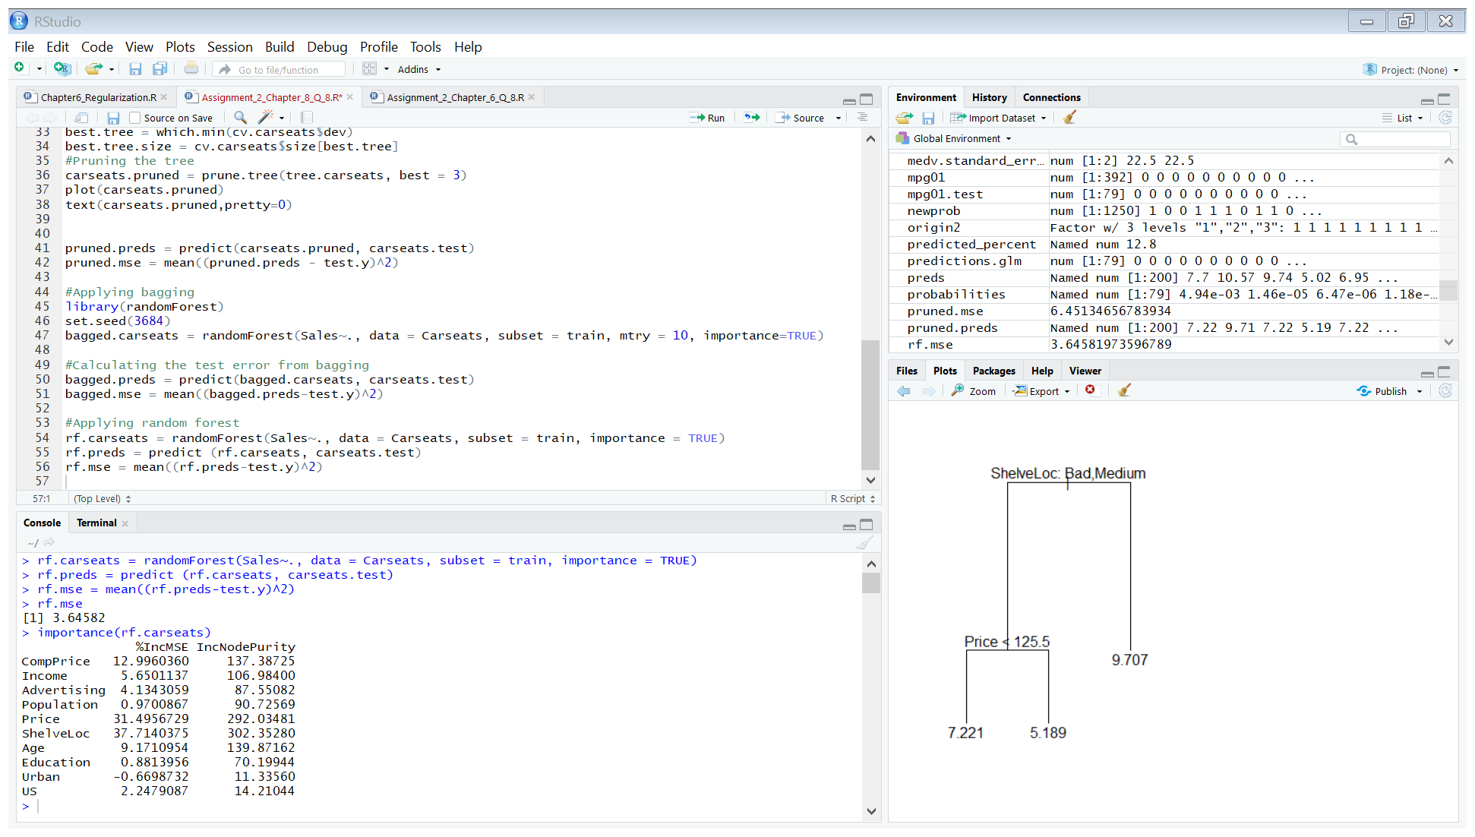

* The importance variables in the prediction of Sales are ShelveLoc and Price.